Digital Inclusion - One to One Pupil Laptop with Vodafone WiFi
Introduction
The devices are setup to allow Dundee City Council School Pupils to learn from home using their home Wi-Fi. They will not work on other networks or with other Dundee Council logins.
The laptops will not provide access to any existing schools shares or data, they are setup for Office365 working. This means that anything that you have saved on your desktop for example will not be there.
The devices are designed to be used as either a laptop or it can be folded into a tablet. The screen is a touchscreen so it can be activated with a finger or the supplied pen.

What’s in the bag?
You get an HP laptop carry bag, with service number label. This label must stay on this bag.
- 1 x HP x360 Laptop
- power supply
- HP pen with 2 AAA batteries
- MiFi Hotspot device
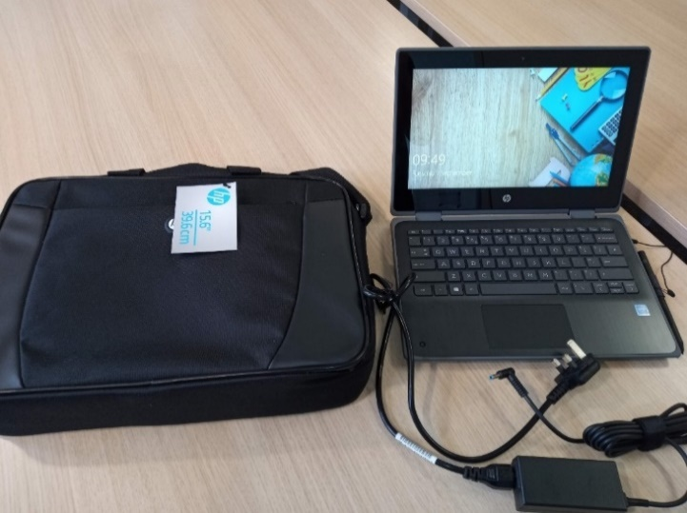
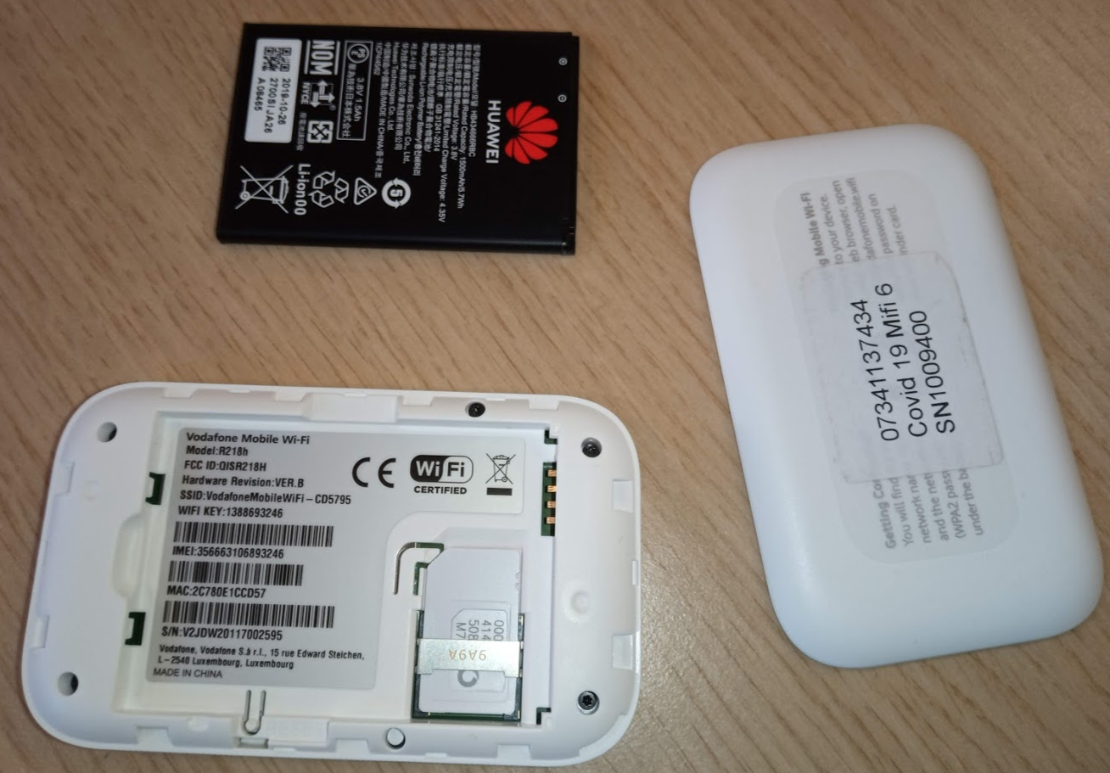

The MiFi hotspot has a Vodaphone 4G Sim card, a power supply to charge the device and a battery when working remotely. As long as the phone signal in your location is good, you will get internet access using your MiFi hotspot.
When the internet is available via Wi-Fi on the device, you will be able to login with your school username and password.
In school, these laptops work only on the Prov network. They will not work on the usual Schools Wi-Fi or the SchoolsBYOD network. Make sure that the laptop is logging into the right one.
The devices are also designed to be used on Home Broadband or a Wi-Fi Hotspot/MiFi device. They will not work without this.
At home, you’ll need to find your home broadband WiFi or MiFi Hotspot password and connect to this. You should only need to do this once – see next section.

Getting Started:
1. Log into WiFi (as you would for your smartphone, if you have one):
You can check the Wi-Fi from the Laptop login screen by pressing any key and then at the bottom right, you will see the internet icon. Select this to show available Wi-Fi.
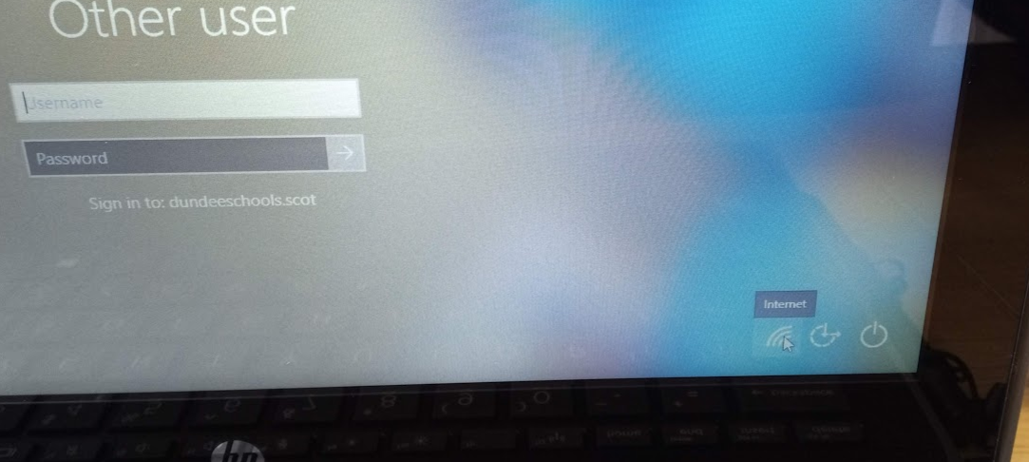

The WiFi access code and service number of the MiFi hotspot device are on a label on the device case and can also be found underneath the battery. This Wi-Fi password is also provided on some of the documentation.
Hold the power button on the front to switch the MiFi hotspot on. You should see your MiFi hotspot listed in the available wireless connections from the laptop after a minute or so. Connect to this with the MiFi hotspot’s Wi-Fi password.

3. Login to the PC
You’ll need a bit of patience the first time you connect. This will take up to an hour to finish, but it’s easy to do and you’ll only have to do this once.
Login with your username and password – these are the same at school and at home. If your username is jbloggs123 when you log in to a PC in school, then jbloggs123 is your log in on this laptop. Your password is the same, too. Remember, these are not your GLOW details. You will need those later, though, in order to access Glow tools like Outlook email and Glow Teams.
The laptop will start to download and install several apps, which will take a bit of time. The screen below shows the Device Setup progress.
The first two sections complete quite quickly but the Account Setup part will take much longer to complete. You can click on Show Details and you will be able to see that the laptop is downloading the allocated applications.

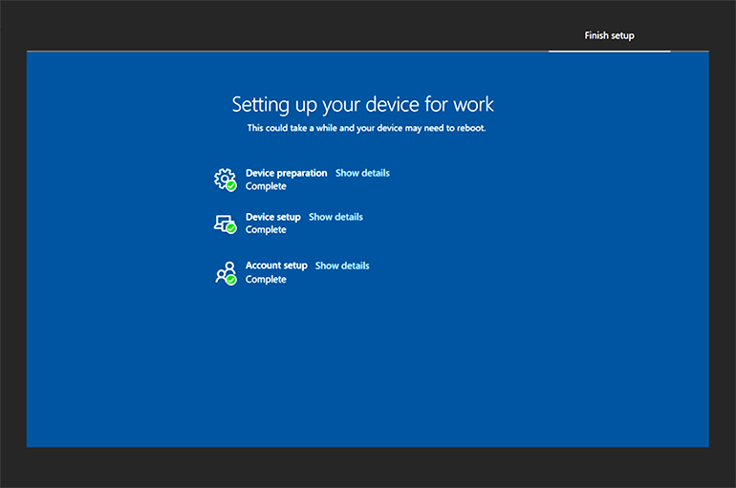

At this point you can continue to log in and get to the desktop if you want. The laptop will still be configuring and downloading applications in the background as long as the device remains on an internet connection. Remember, this will probably take around an hour to complete.
The laptop will require a reboot at some point to complete some of the final setup. After this point, the laptop is ready for use.
Remember that the laptop needs to be on an internet connection like home broadband, MiFi hotspot or the Prov network in school, and can only be used by the pupil it is issued to.

How to Find What You Need
You’ll find some icons like the Edge Chromium internet browser at the bottom on the taskbar. Your access to the internet is filtered, just as it is within school.
Most other apps are found in the Start Menu, at home and in school. Click the Microsoft icon in the bottom left-hand corner to open this Menu. Use these Full Applications (as shown in this screenshot) – don’t use the ‘School essentials’ Web Applications, because these are more limited.

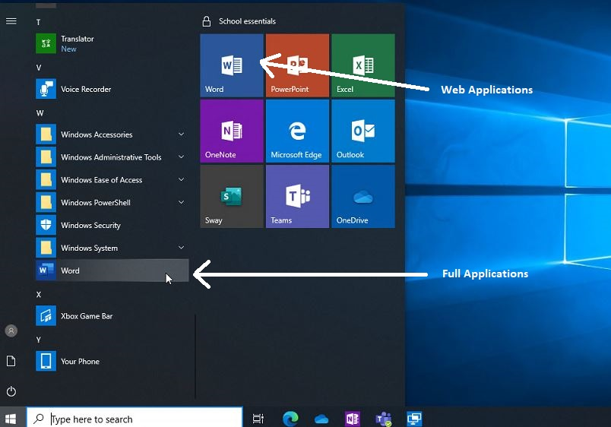
Edge Chromium Web Browser

Logging into Glow Teams
The app in the Start Menu will try to automatically log in via your dundeeschools (DCC) account. You won’t find any of your class Glow Teams in there. Log out then use the Edge web browser to log back in using your Glow login details (dd in front of your username, and whatever password you have chosen).

Cameras
There is a front facing camera with a small slide switch at the top. This will mean you can use video in a Glow Teams lesson.
The camera in the bottom left becomes the front facing camera when in tablet mode.

Saving & Storing
Store your work wherever your teachers ask you to. Often you will simply have to submit work as a Glow Teams Assignment.
You can also save any kind of documents into one of your two OneDrives.
- You have a OneDrive in Glow
- You also have a OneDrive in your dundeeschools account. This is the little cloud icon on the taskbar and might come up as “Dundee City” in the dialogue box when you click save.
Both of these do pretty much the same thing – they store your documents in the cloud. BUT they are not in the same place. Make sure you know which of the two you are saving to!
In school you should already be used to saving to your OneDrives – either the Glow or the Dundeeschools one.
The laptops are not designed to support mass storage devices (also known as flash or pen drives). These devices should not be used on school laptops or desktops either, unless they are encrypted and with a teacher’s permission.

Keeping the Laptop Secure and Undamaged
Please exercise common sense when using and storing this laptop. Keep it away from younger brothers and sisters and any liquids that could spill and damage it. Don’t throw it or hold it by the screen. If using it as a tablet, use the pen supplied. Don’t leave it on the floor where someone could stand on it.
If you’re cleaning the screen, or any other part of the machine, only use approved products to avoid any damage.
The device is monitored using a device management system from DCC’s Education IT team. This means that it can be remotely switched off completely by us. We can also switch on tracking if it is reported stolen. The laptop has no value in the second-hand market because of this, and also because we have recorded its details and the fact that it will not work outside of our networks.
If your device develops a fault, please let a staff member know, as you would with other school equipment. You will need to bring it in for repair.
Lost, stolen or damaged devices must be reported to the school as soon as possible, as detailed in eth User Agreement which you and your parent/carer have signed.

Further Support
Go to the Dundee Online Learning Portal for pupils and parents https://sites.google.com/dd.glow.scot/dundeeonlinelearninghub/home A YouTube video is available at https://youtu.be/7_GgFCysj-4

Returning the Laptop
Laptops should be returned to the school when requested. This may happen from time to time for updates. You must make sure that you have included all the bits outlined on page 1.

