Ancrum Road Primary School
Standards & Quality Report
Session 2016-2017

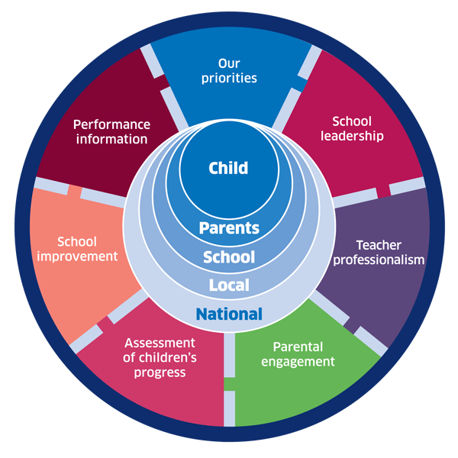 | 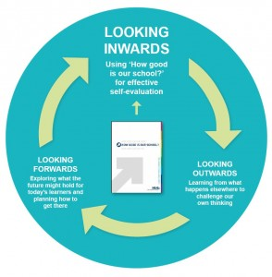
National Improvement Framework  http://www.gov.scot/Publications/2016/01/8314 | HGIOS 4 Self-evaluation https://education.gov.scot/improvement/Documents/Frameworks_SelfEvaluation/FRWK2_NIHeditHGIOS/FRWK2_HGIOS4.pdf | Tayside Plan C&FS  External Link 'Tayside_Plan 1a.pdf'

Creating an annual standards and quality report
Schools must provide an annual standards and quality report, as a record of progress with their annual improvement plan over the previous session and defining the local and NIF priorities for the coming year.
The annual report should ensure that:
- Progress towards NIF drivers and local priorities is communicated clearly and briefly;
- Evaluation of the impact of the school’s actions to improve excellence and equity, and achieve positive outcomes for all children and young people is clear;
- Strategies which have been successful in engaging children and young people, staff, parents and the wider community are highlighted;
- Evaluations for the following QIs are provided: 1.3 Leadership of Change; 2.3 Learning, teaching and assessment; 3.1 Ensuring wellbeing, equity and inclusion; 3.2 Raising attainment and achievement; any other QIs linked to improvement work; and
- An overall evaluation of the school’s capacity for continuous improvement is stated.

Quality Indicator
Quality Indicator | Evidence
1.3 Leadership of change | School Vision, Values and Aims have been updated by the whole school community.  Almost all staff are committed to change which results in improvement for leaners.  Many Staff take responsibility for implementing change, e.g. – Quality Assurance leaders, Numeracy Pioneers, 1 + 2 co-ordinator, Peer Mediation/Bikeability leader, ICT co-ordinator, Reading leaders.  Opportunities for sharing, developing and evaluating practice are built into our working time agreement so all staff and learners benefit from current teaching pedagogies learned about by individuals/groups of staff including SMT.  Through the PRD process, and own self-evaluation, staff identify and commit to CLPL, to support continuous improvement.  SMT work collaboratively with Partnership Schools, cluster, across Dundee and nationally to develop and implement improvement.
2.3 Learning, teaching and assessment | School ethos is inclusive and built upon positive relationships and respect for all.  Positive behaviour policy promotes restorative practice.  Most learners are keen and active participants in their learning.  A range of T and L approaches including digital technologies are used to motivate and engage learners.  Almost all teachers use LIs and SCs consistently. In the best lessons, staff use skilled questioning techniques to engage and challenge learners.  Learners are motivated with their successes, which are displayed as learning journeys and personal achievements.  Planning meetings allow for consistency and moderation with a focus identified and shared with staff.  A range of Data is being used to identify and plan for development needs of individual learners.  Planning identifies what is to be learned and assessed.  Plans for groups/individuals with identified barriers are in place.(ABLe)  A variety of assessment techniques are used in most classes to inform teaching and learning, including say, write, make and do assessments directly related to planned learning.  Tracking systems for Numeracy/Maths and IDL are in place to allow for progression and smooth transition.
3.1 Ensuring wellbeing, equity and inclusion | GIRFEC, Relationships for Learning and Restorative Practice underpin our whole school community.  Staff and partners have a very good understanding of SHANARRI and use the indicators to support the well-being of our community.  Our parents/carers and learners have learned about Children’s Rights and SHANARRI as we have developed our shared Vision, Values and Aims.  Our safe and nurturing environment allows our children to speak about sensitive issues and feel secure that they will be listened to.  Restorative conversations are used by almost all staff to resolve conflict.  Peer mediators have been trained to restore relationships between pupils and are beginning to have an impact.  Most children with identified needs have targeted plans in place.  Opportunities to explore and understand diversity and multi faiths are offered at assemblies, gatherings and in class.  Children challenge discrimination and intolerance when they come across it.  Outdoor space is used by the whole school community and during learning times in class to promote well-being.  Supportive, caring relationships between staff, partners and visitors to our school.
3.2 Raising attainment and achievement | Most leaners at almost all stages are attaining average or above attainment in reading, listening and talking, with the majority attaining average or above in writing. With evidence of a few pupils improving over time.  The majority of leaners at early level are attaining average or above results in standardised testing and CFE levels. In first level most learners are attaining average or above average results. In second level the majority of learners are attaining average or above results.  Teacher judgements based upon evidence and using benchmarks are becoming increasingly more informed and accurate.  Learners are being empowered to give feedback about the quality of their learning experiences and how they think they can be improved.  Increasing opportunities for developing wider achievements are being offered across the school.
2.4 Personalised Support | Universal and targeted support is beginning to be embedded across the school through appropriate challenge and differentiation.  Learners’ needs are identified through assessment and analysing data and are planned for.  The process of staged intervention is known to almost all staff and is followed when children require this.  Parents/carers and children (when age and stage appropriate) are involved in planning of staged interventions.  Support staff are involved in planning for interventions with SMT and class teachers.  ABLe is used to support learners and remove their individual/group barriers

Review of progress for session 2016-2017

School priority 1:
Raising Attainment in Numeracy

NIF Priority  - Improvement in attainment, particularly in literacy and numeracy;  NIF Driver  - Assessment of Children’s Progress  - Performance Information | HGIOS 4  3.2 Raising Attainment and Achievement  2.3 Learning, Teaching and Assessment  2.2 Curriculum
Progress and impact:

Numeracy Pioneers were appointed and attended city-wide maths/numeracy training sessions as well as training in Conceptual Number. Near the end of the sessions CLPL was led by pioneers to share their learning with other staff and to set goals for other staff to work towards for the end of the session and to be carried forward into session 2017-2018.

An audit of setting across P6 and 7 showed that very good progress had been made in P6 and P7 amongst our highest attainers but that this was not replicated in children who were previously showing average and below average attainment.

Consistent tracking of maths/numeracy ensured that across the school there was an understanding and recording of progress which children had made and that next steps in learning could be planned for, better.

Towards the end of the session fluid groups and differentiated challenges not bound by rigid groupings of learners increased motivation and self-challenge of learners in some classes.

Next steps:

Track using new Dundee City digital tracking spreadsheets to ensure more detailed robust data is recorded re progress made by individuals for maths/numeracy.

Use data to plan assessments and next steps in learning for all learners.

Provide a programme of in-house professional learning led by our own Numeracy Pioneers and Staff tutor to ensure all staff are fully trained in Conceptual Number.

Facilitate central training for as many staff as possible in maths/numeracy.

Encourage attendance at maths/numeracy focussed CPD opportunities for all staff.

Fluid groupings to be used across the school.

Differentiated challenges to be set without the restriction of fixed groupings.

School priority 2
Embed the analysis of data across the school in order to improve planning next steps of learning for all, with a particular focus on those who need support.

NIF Priority  Improvement in attainment, particularly in literacy and numeracy  NIF Driver  Teacher Professionalism  Assessment of Children’s Progress  Performance Information | HGIOS 4  3.2 Raising Attainment and Achievement  2.3 Learning, Teaching and Assessment
Progress and impact:

All teaching staff took part in whole school and group/stage training sessions where the analysis of data using mainly PITFALLS but also NGRT and Attainment of a Level data were advanced.

Understanding of data and how it could be used to plan better teaching and learning improved across the school.

Teachers led professional dialogue during forward planning sessions based on their knowledge of data related to their learners.

Plans for a few individuals were created to support their progress/attainment in relation to challenges they faced e.g. understanding of learning, behaviour etc. Some of these plans supported learners to maintain focus and engage better with learning. It is hoped that longer term for these pupils, improvement in attainment will be seen in assessments both Standardised and teacher judgement based.

Next steps

Target learners (SIMD 1 and 2 &FSM) identified by data, who are not so engaged with their learning and not attaining as well, with effective planning for them as individuals, or in small groups to close the attainment gap.

PEF PTs (Raising Attainment) to take responsibility for identifying gaps, making plans to support these gaps and tracking of improvement through Gaps spreadsheet and other measures.

Target all other learners identified by data, who are not attaining, by planning universal and targeted interventions to better meet needs.

Provide extension for able learners, identified by data, by providing learning opportunities, which are planned to create challenges at the next level.

Keep abreast of educational research in order to improve learning and teaching - do some of this through Staff Professional Learning Twitter account.

Create and use in session 2017-2018 tracking system for Literacy.

Tracking of pace to be monitored and challenged at all planning meetings as a focussed priority.

Further, embed tracking procedures to clearly track learner’s progress.

Create opportunities for moderation in school, across the cluster and Dundee, to better ensure consistency, in achievement of levels.

Create Assessment strategy for Literacy, Numeracy/Maths, Health and Well Being and IDL.

School priority 3
Develop confidence and responsibility of all staff in meeting universal and targeted and well-being needs. Create a culture of nurture and support incorporating restorative approaches across the whole school community.

NIF Priority  Improvement in children and young people’s health and wellbeing  NIF Driver  Our Priorities  Teacher Professionalism  Parental Engagement | HGIOS 4  3.1 ENSURING WELLBEING, EQUALITY AND INCLUSION
Progress and impact:

Class teachers took responsibility after professional learning to address barriers to learning within their classes by creating class, group and individual ABLe plans when required.

Professional learning led to staff becoming more aware and contributing to Single Child plans for learners who had specific needs.

New Vision, Values and Aims were created by pupils, parents and staff after consultation with all. An adult and a child friendly version of our V, V and As were created in order for all to have a full understanding of what these mean.

Relationships for Learning training was delivered by DEPS staff for all school staff. Principles of this were advocated and adopted in order to support a nurturing ethos throughout the school.

Restorative Practice training was delivered by DEPS and school staff to all teachers and support staff, as well as sessions being run for interested parents. Links to reading for other parents were tweeted.

Restorative Questions were displayed in every room and around the school as an aide memoire for everyone to use in their practice when supporting learners to resolve conflicts and find ways forward.

A member of staff was trained in Peer Mediation and led this initiative in her own P6 class. Pupil Peer Mediators were trained and appointed to this role and began to play a part in conflict resolution in the playground with their younger peers.

Next steps:

Continue to build knowledge of how GIRFEC, Relationships for Learning and Restorative Practice are essential for learning.

Have planned group of assemblies which focus on Children’s Rights and SHANARRI so that all children can understand and use these to have better lives.

Promote more awareness of SHANARRI to our parents and carers.

Increase awareness of diversity and understanding of it.

Train another group of peer mediators and facilitate peer mediation by providing suitable outdoor private space for conversations.

Plan for more Fun Fit Friday sessions to use our outdoor spaces with whole school community to promote well-being for all.

Session 2017/18 Priorities

School Priority | NIF Priority | NIF Driver | HGIOS 4
- To improve attainment in numeracy at all levels | Improvement in attainment, particularly in literacy and numeracy; | School Improvement  Assessment of Children’s Progress  Performance Information | 3.2 Raising Attainment and Achievement  2.3 Learning, Teaching and Assessment  2.2 Curriculum
- To improve attainment in literacy, particularly in reading and writing at all levels | Improvement in attainment, particularly in literacy and numeracy; | School Improvement  Assessment of Children’s Progress  Performance Information | 3.2 Raising Attainment and Achievement  2.3 Learning, Teaching and Assessment  2.2 Curriculum
- To raise attainment for all of our least advantaged children | Closing the attainment gap between the most and least disadvantaged children | School Improvement  Parental Engagement | 3.1 Improving Wellbeing, Equality and Inclusion  1.5 Management of Resources to Promote Equity  2.5 Family Learning

