Ancrum Road Primary School Interdisciplinary Learning for Planning Block 2 2020-2021 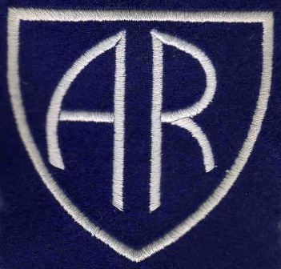

Teachers: Mrs Wilson and Miss Anderson Class: P7

Interdisciplinary Learning is a planned experience that brings curricular areas e.g. science/social subjects/expressive arts, together in one coherent programme or project.
The different curricular areas are linked together as one.
IDL enables children and young people to
● learn new knowledge or skills, and develop new understanding of concepts
● draw on prior knowledge, understanding and skills
● transfer and apply that collective knowledge to new problems or other areas of learning.

In each planning block for 2020-2021 a Main Focus of Learning will be identified and other areas which link to this area will be planned for (not all curricular areas will be studied at once).
Over the course of one session all curricular areas will be studied.
The Curriculum for Excellence Experiences and Outcomes which teachers plan for, will be detailed for you to see, along with a description of the main learning.
How you can help to support this learning at home will also be detailed.
The context of the learning will also be detailed.

 | Planning Block 3 - Jan – end March 2021
Main Curricular Area/s | RME/Social Studies/Expressive Arts
Social Subjects focus | I can gather and use information about forms of discrimination against people in societies and consider the impact this has on people’s lives. SOC 2-16b
Science focus

Health and Well Being focus

Technologies focus
RME focus | I am developing respect for others and my understanding of their beliefs and values. RME 2-07a  I can explain why different people think that values such as honesty, respect and compassion are important, and I show respect for others. RME 2-09c
Expressive Arts focus | I have created and presented scripted or improvised drama, beginning to take account of audience and atmosphere. EXA 2-14a
Literacy | To show my understanding, I can respond to literal, inferential and evaluative questions and other close reading tasks and can create different kinds of questions of my own. ENG 2-17a  By considering the type of text I am creating, I can select ideas and relevant information, organise these in an appropriate way for my purpose and use suitable vocabulary for my audience. LIT 2-26a

Numeracy
Context of Learning | The Divided City

How you can support your child with this learning:
- Find real life items in the news e.g. in newspaper articles, Newsround etc. linked to prejudice and discrimination and discuss with your child.
- Discuss the issue of racism with your child using sites such as Unicef and Show Racism The Red Card for guidance and support.
https://www.unicef.org/parenting/talking-to-your-kids-about-racism
https://www.theredcard.org/

- Watch some short films to explore and investigate a variety of Religions and religious beliefs e.g. BBC Teach
https://www.bbc.co.uk/teach/ks2-religious-studies/z6pbqp3

For Information
The above IDL plan was expected to be delivered during block 3, from Jan – March 2021. It was thought however, due to the complex nature of the content of some of the lessons and the need for discussion and collaborative work, that this would be best delivered in a classroom environment, face to face with the children as opposed to online learning. As such, whilst we continued with the Literacy section of the plan, our IDL focus shifted more towards Social Subjects and Expressive Arts within the context of Scotland. We have decided therefore to continue with the above IDL plan for block 4, April – June.

