Ancrum Road Primary School Interdisciplinary Learning for Planning Block 2 2020-2021 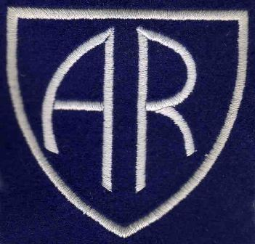

Teacher/s: Mrs Johnstone, Miss Ezell & Miss Barr Class: P4/3 & P4

Interdisciplinary Learning is a planned experience that brings curricular areas e.g. science/social subjects/expressive arts, together in one coherent programme or project.
The different curricular areas are linked together as one.
IDL enables children and young people to
● learn new knowledge or skills, and develop new understanding of concepts
● draw on prior knowledge, understanding and skills
● transfer and apply that collective knowledge to new problems or other areas of learning.

In each planning block for 2020-2021 a Main Focus of Learning will be identified and other areas which link to this area will be planned for (not all curricular areas will be studied at once).
Over the course of one session all curricular areas will be studied.
The Curriculum for Excellence Experiences and Outcomes which teachers plan for, will be detailed for you to see, along with a description of the main learning.
How you can help to support this learning at home will also be detailed.
The context of the learning will also be detailed.

 | Planning Block 4 - April – June 2021
Main Curricular Area/s | Kindness Around the World
Social Subjects focus
Science focus
Health and Well Being focus | I know that friendship, caring, sharing, fairness, equality and love are important in building positive relationships. As I develop and value relationships, I care and show respect for myself and others. HWB 1-05a
Technologies focus
RME focus | Having explored biblical and other Christian stories, I can show my developing understanding of key values of Christianity and how they might be put into action in people’s lives and communities. RME 1-02a  I can describe the key features of the values of Christianity which are expressed in stories. RME 1-02b  Having explored stories from world religions, I can show my developing understanding of key values of those faiths and how they might be put into action in people’s lives and communities. RME 1-05a  I can describe the key features of the values of world religions which are expressed in stories. RME 1-05b  I can show my understanding of values such as caring, sharing, fairness, equality and love. RME 1-09b
Expressive Arts focus | I enjoy creating, choosing and accepting roles, using movement, expression and voice.  EXA 1-12a

Literacy

Numeracy
Context of Learning | Kindness Around the World  The children will be learning about world religions and their values. They will be introduced to religious stories and the morals these stories teach us then link this to our own values. The children will also take part in expressive art activities related to these religions and their festivals.

How you can support your child with this learning:
Kindness Around the World
- Research world religions at home online.
- Visit or locate places of worship around Dundee (if COVID-19 restrictions allow).
- Carry out acts of kindness at home and in the community.
- Play charades at home to allow children to practise drama movements.

