**Class: P7 Teacher: Miss Shek, Miss Anderson and Mr Hendry Grid 11 W.C. 15th June**

|  |  |  |
| --- | --- | --- |
| **Literacy**  **See *‘Core Learning Activities’* for details of reading, writing and talking and listening weekly learning activities.**  **Remember to complete the Sumdog spelling challenges.**  **Don’t forget to let your teacher see how you are doing by posting your work onto your Microsoft team page.**perform their scripts, and if recording equipment is available, create their own mock radio or television item. | **Numeracy and Maths:**  **See *‘Core Learning Activities’* for details of numeracy and maths weekly learning activities.**  **Remember to complete the Sumdog numeracy challenges.**  **Don’t forget to let your teacher see how you are doing by posting your work your Microsoft team page.** | **Health and Wellbeing**  Write a letter to your future self, telling them about this time you are living in now. You are making history every day and you will enjoy reading it one day.  Make a list of things you want to do or achieve after lockdown.  What was the best feeling you ever had? Write it on a piece of paper and decorate it. |
| **ICT/Technologies**  Visit https://hourofcode.com/uk/learn  Choose one of the activities and follow the tutorial videos. | **Religious and Moral Education**  Can you research and answer the following questions about Buddhism?  1. How is Buddhism different from other religions?  2. Who is the founder of Buddhism?  3. Which country did Buddhism originate in?  4. What is the Buddhist house of worship called?  5. What is the name of the Buddhist sacred text?  6. What are the three main symbols of Buddhism? | **Cross Curricular**  Racism in society **Black Lives Matter**  Attached to this learning grid are some resources relating to Racism and the Black Lives Matter movement.  Read through these and complete one or both of the following activities.  1. Create a fact file on an individual influential to the black civil rights movement.  2. Create a poster promoting black civil rights. |
| **Social Skills (Helping at home)**  Do three household jobs from the following list to help your family.  1. Make your own bed.  2. Set the table for lunch or dinner.  3. Take the dog out for a walk.  4. Clean your pet’s cage or eating bowl.  5. Feed your pet.  6. Tidy your room.  7. Pick out the weeds in your garden.  8. Make your own breakfast.  9. Wash the dishes.  10. Dust your room. | **Art and Design**  Why not find a stone or a pebble and paint it?  Your design can be anything you like. You may want to paint lots of pebbles/stones displaying a theme. Remember to be as creative as possible as anything goes.  Take a picture of your creations and post them on your Microsoft team page for others to see.  I have put some examples on the page attached to this learning grid. | **Science**  Growing Crystals  Try the science experiment attached below to the learning grid.  Did your experiment work?  Why do you think the salt crystals behave in this way?    I will post what is actually happening to the salt in this experiment next week and you can compare this to your own thoughts. |



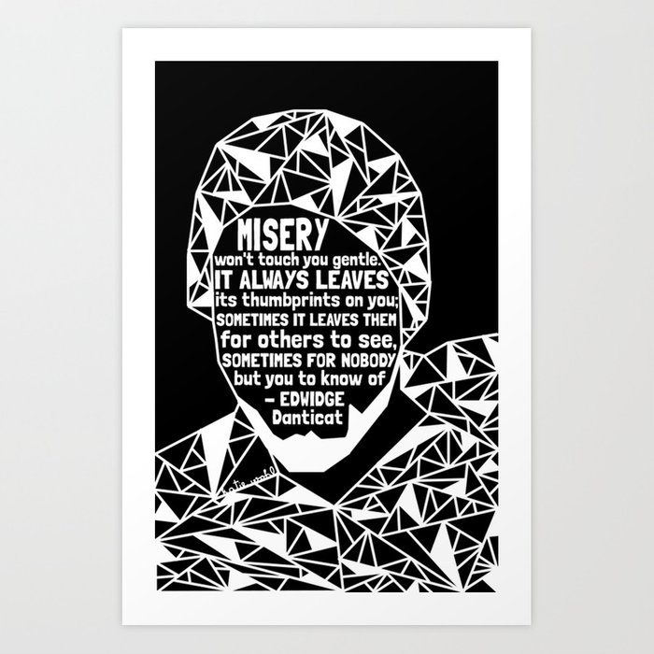





[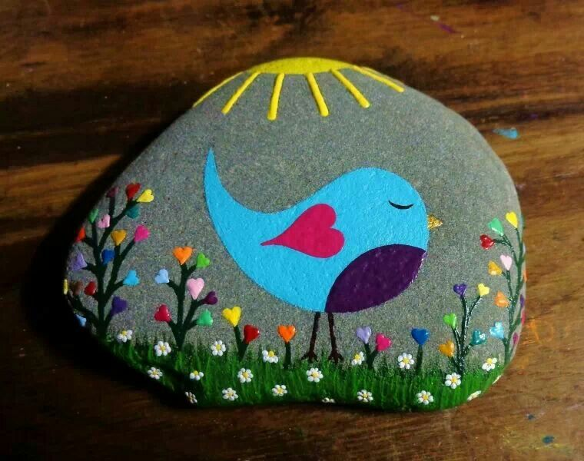](https://www.google.com/url?sa=i&url=https%3A%2F%2Fwww.pinterest.com%2Fpin%2F478085316682947887%2F&psig=AOvVaw3nEffN87iRvfwwff8qee1M&ust=1591813228101000&source=images&cd=vfe&ved=0CAIQjRxqFwoTCPjyo8Os9ekCFQAAAAAdAAAAABAL) [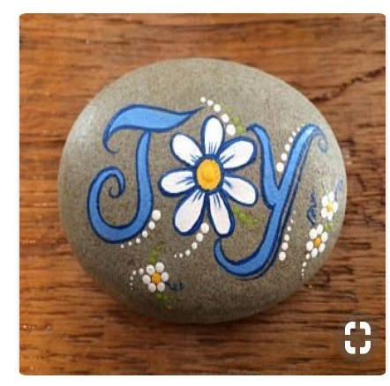](https://www.google.com/url?sa=i&url=https%3A%2F%2Fwww.pinterest.com%2Fpin%2F335799715965360388%2F&psig=AOvVaw3nEffN87iRvfwwff8qee1M&ust=1591813228101000&source=images&cd=vfe&ved=0CAIQjRxqFwoTCPjyo8Os9ekCFQAAAAAdAAAAABAV)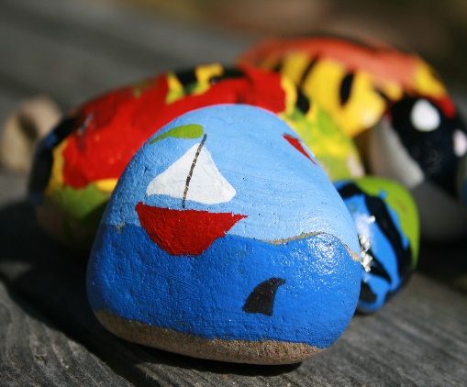 [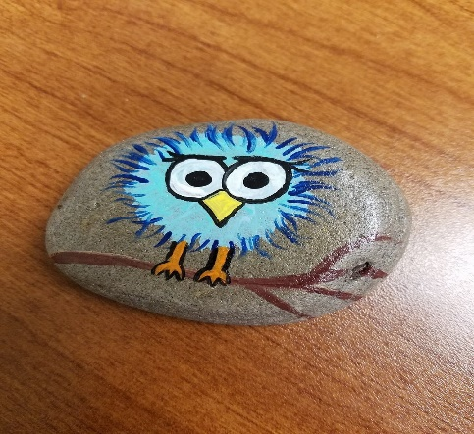](https://www.google.com/url?sa=i&url=https%3A%2F%2Fwww.pinterest.com%2Fpin%2F43628690125086823%2F&psig=AOvVaw3nEffN87iRvfwwff8qee1M&ust=1591813228101000&source=images&cd=vfe&ved=0CAIQjRxqFwoTCPjyo8Os9ekCFQAAAAAdAAAAABAQ)

[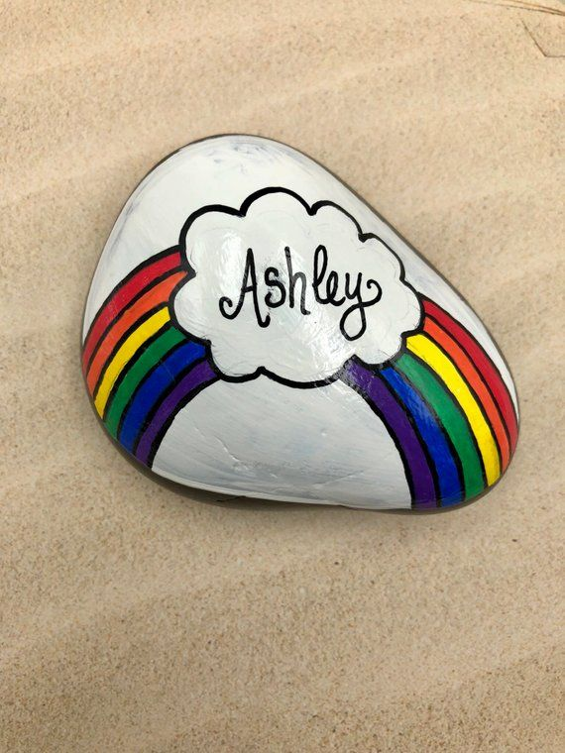](https://www.google.com/url?sa=i&url=https%3A%2F%2Fwww.pinterest.com%2Fpin%2F244320348520914810%2F&psig=AOvVaw3nEffN87iRvfwwff8qee1M&ust=1591813228101000&source=images&cd=vfe&ved=0CAIQjRxqFwoTCPjyo8Os9ekCFQAAAAAdAAAAABAp) [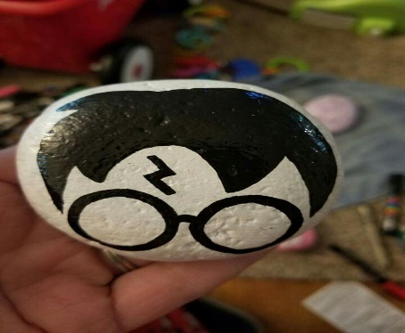](https://www.google.com/url?sa=i&url=https%3A%2F%2Fwww.pinterest.com%2Fpin%2F220254238010878888%2F&psig=AOvVaw23r_WnkfIx-cCv1rcQcJev&ust=1591813874766000&source=images&cd=vfe&ved=0CAIQjRxqFwoTCNCU-vau9ekCFQAAAAAdAAAAABAN) [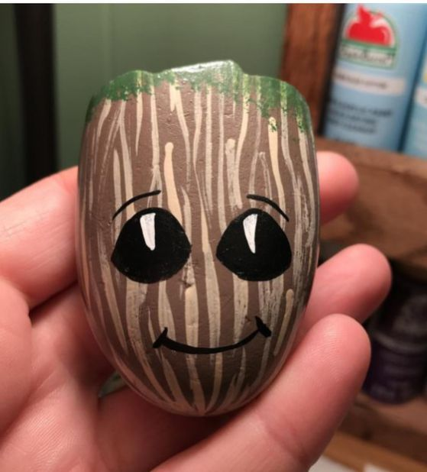](https://www.google.com/url?sa=i&url=https%3A%2F%2Fwww.pinterest.com%2Fpin%2F203365739409490249%2F&psig=AOvVaw23r_WnkfIx-cCv1rcQcJev&ust=1591813874766000&source=images&cd=vfe&ved=0CAIQjRxqFwoTCNCU-vau9ekCFQAAAAAdAAAAABAS) [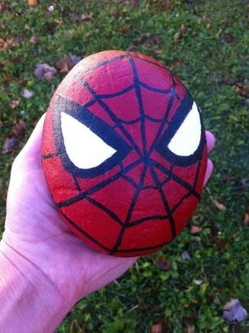](https://www.google.com/url?sa=i&url=https%3A%2F%2Fwww.pinterest.com%2Fpin%2F803470389753482963%2F&psig=AOvVaw0fLQcvdkOgvp2MvJ8Sy_bY&ust=1591814044920000&source=images&cd=vfe&ved=0CAIQjRxqFwoTCJjescmv9ekCFQAAAAAdAAAAABAJ)

[](https://www.google.com/url?sa=i&url=https%3A%2F%2Fwww.pinterest.co.uk%2Fpin%2F21673641944004142%2F&psig=AOvVaw0fLQcvdkOgvp2MvJ8Sy_bY&ust=1591814044920000&source=images&cd=vfe&ved=0CAIQjRxqFwoTCJjescmv9ekCFQAAAAAdAAAAABAS) [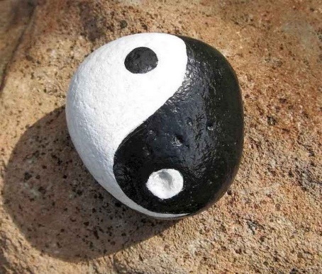](https://www.google.com/url?sa=i&url=https%3A%2F%2Fwww.pinterest.com%2Fpin%2F87398049005941801%2F&psig=AOvVaw0fLQcvdkOgvp2MvJ8Sy_bY&ust=1591814044920000&source=images&cd=vfe&ved=0CAIQjRxqFwoTCJjescmv9ekCFQAAAAAdAAAAABAZ) [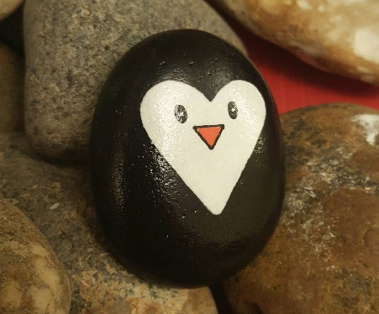](https://www.google.com/url?sa=i&url=https%3A%2F%2Fwww.pinterest.com%2Fpin%2F510173464041828831%2F&psig=AOvVaw0fLQcvdkOgvp2MvJ8Sy_bY&ust=1591814044920000&source=images&cd=vfe&ved=0CAIQjRxqFwoTCJjescmv9ekCFQAAAAAdAAAAABAf) [](https://www.google.com/url?sa=i&url=https%3A%2F%2Fwww.pinterest.com%2Fpin%2F537054324314823388%2F&psig=AOvVaw0fLQcvdkOgvp2MvJ8Sy_bY&ust=1591814044920000&source=images&cd=vfe&ved=0CAIQjRxqFwoTCJjescmv9ekCFQAAAAAdAAAAABAs)