Class: P7 Teacher: Miss Shek, Miss Anderson and Mr Hendry Grid 8 w.c 25th May
Literacy  BBC Bitesize-All Bitesize- Scotland- Second Level-Literacy and English. Go to Listening and Talking- Finding and using information class clips. Choose The sinking of the Titanic – breaking news report.  Watch the mock news report and copy the style of the report to write a script for a similar news report on an event of your choice.  You could even perform your script and create your own mock radio or television item. | Numeracy and Maths: What is Tessellation?  The BBC Bitesize clip below the grid is there to remind you. Click on the interactivity attached to explore tessellations further.  https://nrich.maths.org/6069  Describe your tessellating pattern.  Draw a shape that won’t tessellate.  What combination of shapes might you  put together make a hexagon? Are there  any others? Links to the real world: Look for examples of tessellations at home or in the media. Sketch any examples you find.  Remember to log on to Sumdog for your weekly challenges. | Health and Wellbeing  Make a playlist of your favourite feel-good music. Keep adding to the playlist every day as you think of more music that makes you feel happy. Every day, spend some time dancing to music from your playlist. If you are able to, get together with other people (e.g. at home, or friends via social media) and dance together to each other's playlists.
ICT/Technologies  Every day, keep in touch with someone you can't see face to face. You can do this by phone, text, Skype, WhatsApp etc - use whatever technology you have available to connect with people you care about. This could be your friends, your grandparents, or other relatives, your teacher, for example. | Religious and Moral Education  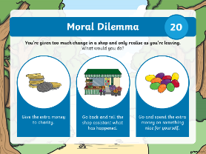  Consider the moral dilemma below the grid.  What would you do?  Make a dilemma for others to try and decide what to do.  Your situation must include a difficult choice with good and bad points to both sides. | Cross Curricular  Different diets  Make a food diary for what you eat in a day. What different types of food do you eat? How could you group them? Do you have a pet? Make them a food diary or research the diet of another animal. How does their diet compare to yours?  https://bit.ly/2Se76CQ
Social Skills (Helping at home)  Make a list of chores that need done around the home and create a weekly planner which details your responsibilities e.g. hanging up the washing, making your bed, cleaning out your hamster’s cage etc. Each time you complete a chore, draw a smiley face next to your completed task. Maybe you could even agree a small reward for completing your tasks. | 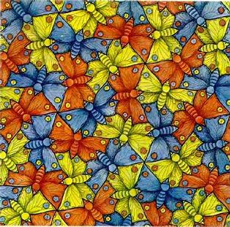  Art and Design  Escher (1898-1972) was a Dutch graphical artist most famous for his impossible structures and mathematical tessellations.  Follow the instructions provided below the grid to make your own tessellation art. | Science  Intriguing Ice  Watch the short video below the grid looking at what happens to different liquids when they are frozen.  After watching, choose some everyday liquids and freeze them, then observe what happens to them.
Numeracy and Maths https://www.bbc.co.uk/bitesize/topics/zjv39j6/articles/zgxwfcw
Science https://www.stem.org.uk/resources/elibrary/resource/33254/intriguing-ice
Art and Design Religious and Moral Education
