Class: P7 Teacher: Miss Shek, Miss Anderson and Mr Hendry Grid 6 w.c 11th May
Literacy  In an abandoned industrial landscape one man goes in search of a place that holds strong memories for him.  Writing  -Listen to ”Faded” on the following link and answer the key questions provided below the grid.  https://AlanWalker.lnk.to/faded  -Write a 1st person recount of what happens in the video, remember to use descriptive language for effect. | Numeracy and Maths  Can you solve the following numeracy problem in a systematic way.  St Ives  As I was going to St Ives, I met a man with seven wives. Every wife had seven sacks, every sack had seven cats, every cat had seven kittens. Kittens, cats, sacks and wives, how many were going to St Ives?  Remember to log on to Sumdog for your weekly challenges. | Health and Wellbeing  - Make up your own aerobic dance routine to a favourite song and share your routine on Twitter.  - Complete a Joe Wicks workout from Youtube each morning.  - Go for a 20 minute walk and spend some time enjoying nature - it can feel really easy to end up spending more and more time on your phone or laptop and therefore cooped up indoors. A lot of people find fresh air helps them to relax. Take a photo of yourself enjoying your walk and share it on our Twitter page.
ICT/Technologies  Following on from last week, use a smartphone, iPad or tablet and video yourself as an aerobic instructor, sharing your aerobic dance moves to your favourite song. Send it to a friend/ family member and challenge them to take part in your routine.  Ask a parent to help you send it to your chosen person or share it on our Twitter page. | Religious and Moral Education  Learn all about how and why Muslims participate in the month of Ramadan and how they celebrate at the end of the month with Eidul-Fitr. https://www.bbc.co.uk/bitesize/articles/zdgrcqt Just as Muslims go without food and drink during Ramadan, people have had to give up lots of things during the lockdown. Muslims make special plans for the end of Ramadan. What special plans would you like to make for when lockdown ends? | Cross Curricular  -Plan an evening meal with a starter, main and dessert based on the ‘Eatwell plate’.  -Select some food preparation techniques to investigate. Demonstrate them (if possible). Choose from rolling, chopping, kneading, coring, whisking, draining, cleaning, whipping or mixing).  -Pick one food item to research and create a ‘food journey’ for it (think about how this food item ends up in our shops). Present this in any form.
Social Skills (Helping at home)  -Write a quiz for your household. Pick 5 different topics and make up 5 questions for each. Be the host of the quiz and ask the questions. You could include other family or friends using digital technologies.  -Search ‘SingingHandsUK’ on YouTube and select a song to learn in Makaton (Shotgun is great). Try to learn the song or just the chorus. Perform it for a family member if you are feeling confident. | Art and Design  The clip below shows the artist Banksy spraying his own house walls during lockdown.  https://www.bbc.co.uk/newsround/52306587  Research Banksy’s work and create your own piece of Banksy art – on paper of course!  Please share these on Twitter for us to see, remember to ask an adult to help you to do this. | Science  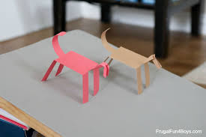  Make a paper horse that walks and challenge someone in your house to a race! See the link below for full instructions on how to make your horse and the physics behind this fun activity. https://frugalfun4boys.com/paper-horse-that-walks/

“Faded”
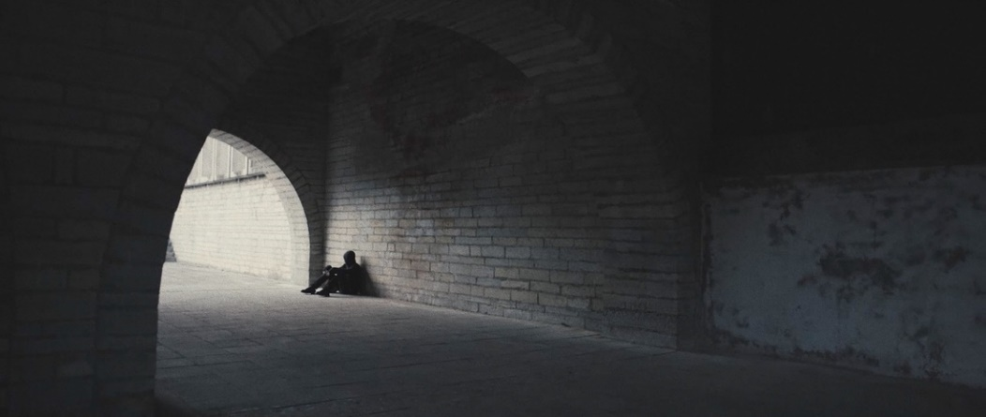

Key Questions:
- Why is everywhere empty and derelict?
- Who is the man in the mask? Is he trying to keep his identity hidden?
- What is he thinking as he looks at the photograph?
- Where is he going?
- How do the lyrics link with the moving images?
- After he has set off - Where do you think he is going? Why?
- How do the characters feelings change throughout the film? How does the director show this?
- How does he feel when he sees the house?
- Whose house was it?
- What happened there?
- Why does he drop the photograph?

https://www.literacyshed.com/faded.html

