Class: P7 Teacher: Miss Shek, Miss Anderson, Mr Hendry Grid 10 w.c 8th June – Mrs Wilson
Literacy  See ‘Core Learning Activities’ for details of reading, writing and talking and listening weekly learning activities.  Remember to complete the Sumdog spelling challenges.  Don’t forget to let your teacher see how you are doing by posting your work onto your Microsoft team page. | Numeracy  See ‘Core Learning Activities’ for details of numeracy and maths weekly learning activities.  Remember to complete the Sumdog numeracy challenges.  Don’t forget to let your teacher see how you are doing by posting your work your Microsoft team page. | 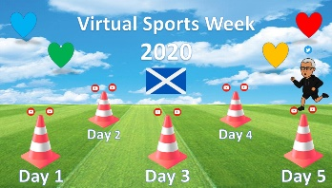  Health and Wellbeing  Take part in this Thinglink Virtual Sports Week. Try a sports challenge every day and share your attempts on Twitter and Teams if you can. Find the Thinglink link below the grid.
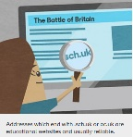  ICT/Technologies: Go to BBC Bitesize/All Bitesize/Scotland/2nd Level Computing Science and ICT. In Safe and appropriate conduct/ Should I trust everything I read on the web? Read the information provided and watch the Evaluating Digital Content link. Carry out some research on an appropriate topic of your choice and determine whether the information you have found can be trusted. | Religious and Moral Education    Consider this moral dilemma. Make a list which includes both good and bad points to support both sides. | Cross Curricular  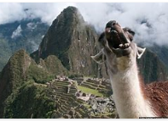  Take a Virtual Trip to Machu Picchu, Peru.  Experience Machu Picchu, one of the seven wonders of the world, through 360 photos. Click on the page to listen to some interesting facts and click on the arrow pointing right at the right of the page to move on to the next viewpoint.  https://www.youvisit.com/tour/machupicchu?pl=f Complete the task below the grid.
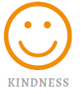  Social skills (working from home)  Make a list of seven kind things you can do for someone else. This could be for people you live with (e.g. do the dishes one evening, tidy your room, read with your brother or sister) or people you don't get to see every day (send someone a compliment by text, draw a picture and send a photo of it to your grandparents, etc). Each day, do one of the seven kind things from your list. | 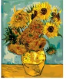  Art and Design: Sunflowers is the name of two series of still life paintings by the Dutch painter Vincent van Gogh. The first series, executed in Paris in 1887, depicts the flowers lying on the ground, while the second set, made a year later in Arles, shows a bouquet of sunflowers in a vase. Watch the video below and see if you can recreate the second set in the ‘Sunflowers’ series.  https://www.youtube.com/watch?v=rU_-LTH2Qts | 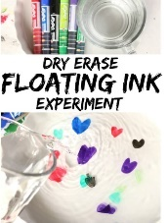  Science Making Ink Float  Follow the instructions below the grid and make observations as requested.
Cross Curricular
- Plan your journey to the place have visited. How far away is it in miles? How would you travel there? How long would it take? How much would transport cost? Where would you stay?
- Write a list of things you would need to pack when visiting this place.
- Use Google Maps to find the place you have visited. What other landmarks or interesting buildings can you find nearby?
Health and Wellbeing
https://www.thinglink.com/card/1322897117651402754

Science

Science
https://www.youtube.com/watch?v=56diV8cdeDc&feature=youtu.be

Make observations
- Is there a colour of ink that works best? Is it the colour of the ink? Does it depend how thick the layer of ink is?
- Which drawing surface works best? Try a variety of different surfaces.
- Do solid shapes float better than stick figures or letters?
Experiment with different types of drawings – letters, pictures, outlines, solid shapes etc. to see which ones float best.
- Can you pick up your floating shapes!
What’s really cool is that we were able to pick up our floating shapes with our fingers. When we did, they completely deflated and looked like a little strand of rubber, but when we gently placed them back on the surface of the water and jiggled them a little, they expanded back into their original shape and floated again.
- Does the temperature of the water make a difference? Try your experiment with hot, cold and room temperature water and observe your results.

And have fun trying the experiment over and over again!

