Stage: Stage: P5 Mrs Martin, Mrs Stephen, Miss Wilkinson, and Mrs Johnstone. Grid 11 Week beginning:15.6.2020
Literacy  SEE CORE LITERACY PAGE for this week’s challenges!  Every week  - Try to read aloud every day. Read to a sibling, a parent, someone on the phone even to a pet! Dogs and cats love having stories read to them!  - Pick a novel or information book to read for enjoyment.  - Complete your spelling/grammar challenges on Sum Dog every week. | Numeracy and Maths  SEE CORE MATHS AND NUMERACY for this week’s challenges!  Every week  - Practice your mental maths skills every week. Working answers out in your head with no paper is a really important skill in life.  - www.solvemoji.com  Emoji Math Puzzles & Games – this is so much fun! These are good warms ups to get your brain going!  - http://topmarks.co.uk  Maths games  - Complete your numeracy and maths challenges set on Sum Dog by your teacher. | Health and Wellbeing  Can you self-reflect on your year at school and write a letter to your teacher about all the memories that you have of your time in the class. You can post or email this to your teacher for them to enjoy!  This week make a 30 minute home fitness workout. Think of 6 exercises you can complete in a circuit. Star jumps, toe touches, sit ups, press ups, lunges, burpees.  Every week  - Complete a Joe Wicks workout!  - Go for a 20 minute walk.  - www.gonoodle.com – activities.  - Cosmic Yoga workout.  - Listen to some feel good music.  - Dance & move to your favourite music.
ICT/Technologies  - Watch Newsround everyday this week. Video yourself doing a news report.  - www.code.org has activities such as an Hour of Code. | Religious and Moral Education  With an adult, discuss the importance of the following morals – courage, loyalty and empathy. Talk about times when you have shown these qualities.  Create an inspirational saying for example:  Good words are worth much, and cost little. | Cross Curricular  http://powerlanguage.school/  This is a website that teachers use to help them teach French. They have developed lessons you can do at home. Follow the link and select Courses for families. There are six lessons in French. Bonne Chance!  Complete lessons 5 & 6 this week. This week you will be learning to say how old we are and ask someone how old they are. There is also a revision section.
Social Skills (Helping at home)  Write a letter to your new teacher!  Let them know who you are, what your favourite school activities are and what you have been up to during the final term. Email or post them in teams for your teacher to pass on to your future teacher!  Write a list of 10 jokes. Tell them to your family and friends. How many laughs did you get?  My kids laugh as they are telling jokes and you can’t even hear what they are saying!  My dad laughs at his own jokes but nobody else gets them!  - Help an adult cook a meal.  - Help with a household chore.  - Keep your bedroom tidy. | Art and Design  http://www.robbiddulph.com/draw-with-rob  Try out one of the drawing tutorials on this website.  If you are feeling extra creative, you could create your own drawing tutorial and share it with the rest of the class.  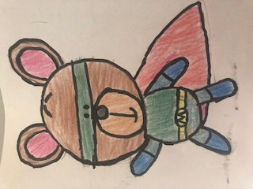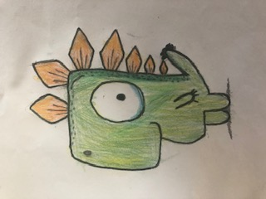  By Max Martin | Science  It has just been National Food Safety week. This week I would like us to think about food poisoning. There is a great deal of information on http://www.foodafactoflife.org.uk/ if you type into the search bar food poisoning. Try to find the answer to the following questions:  - Name 3 high risk foods in terms of food poisoning.  - Name the common symptoms of food poisoning.  - List two tips for storing food safely at home.

