Stage: Stage: P5 Mrs Martin, Mrs Stephen, Miss Wilkinson, and Mrs Johnstone. Grid 10 Week beginning: 8.6.2020
Literacy  SEE CORE LITERACY PAGE for this week’s challenges!  Every week  - Try to read aloud every day. Read to a sibling, a parent, someone on the phone even to a pet! Dogs and cats love having stories read to them!  - Pick a novel or information book to read for enjoyment.  - Complete your spelling/grammar challenges on Sum Dog every week. | Numeracy and Maths  SEE CORE MATHS AND NUMERACY for this week’s challenges!  Every week  - Practice your mental maths skills every week. Working answers out in your head with no paper is a really important skill in life.  - www.solvemoji.com  Emoji Math Puzzles & Games – this is so much fun! These are good warm ups to get your brain going!  - http://topmarks.co.uk  - Complete your numeracy and maths challenges set on Sum Dog by your teacher. | Health and Wellbeing  This is National Bike Week! Design a helmet that you would wear on a bike. People of all ages are recommended to wear helmets, they can save lives. Remember to make air gaps so it is breathable.  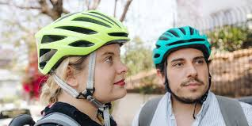  Every week  - Complete a Joe Wicks workout!  - Go for a 20 minute walk.  - www.gonoodle.com – activities.  - Cosmic Yoga workout.  - Listen to some feel good music.  - Dance & move music.
ICT/Technologies  - www.code.org has activities such as an Hour of Code.  - www.dkfindout.com  The above DK website has a lot of information about coding. Have a look and read the sections on what is coding? Eight cool facts about computer coding. What is the World Wide Web? What is the internet? | Religious and Moral Education  People who made history. Research one person from history or in the present. Write a couple of paragraphs about how they changed the world for the better.  Suggestions to get you started:  - Christopher Columbus  - Mother Teresa  - Emmeline Pankhurst  - Nelson Mandela | Cross Curricular  http://powerlanguage.school/  This is a website that teachers use to help them teach French. They have developed lessons you can do at home. Follow the link and select Courses for families. There are six lessons in French. Bonne Chance!  Complete lessons 3 & 4 this week. This week you will be learning to say where we live and ask someone else where they live. We will then move on to sharing our nationality.
Social Skills (Helping at home)  - Make your bed.  - Make your own breakfast.  - Put your electronic devices away for a few hours and go out into the fresh air.  - Make up a game. I got my fitness ball from the garden and made it into ball to roll into the paddling pool on!!!!! | Art and Design  Zentangle – Make a Zentangle picture of your name in bubble writing. See below for examples of patterns you could use.  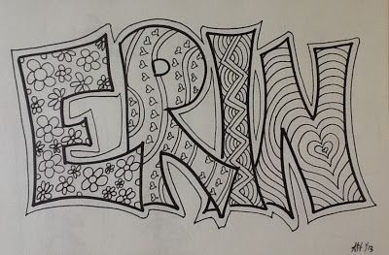 | Science  This week marks World Ocean Day (Monday 8thJune.) www.worldoceansday.org has lots of great suggested activities.  Create a campaign poster. Help turtles, sharks, seals, humpback whales to have a safe home in the ocean.  Pick a creature and design a poster which has:  - A picture of the animal you have chosen.  - A large title such as “HELP!”  - Information saying why this animal needs help.
