**Stage: P2 Teachers: Miss Barr, Miss Wilson and Mr Mitchell**

|  |  |  |
| --- | --- | --- |
| **Literacy**  See ‘Core Learning Activities’ for details of read, writing and talking and listening weekly learning activities.  Remember to complete the Sumdog spelling challenges.  Don’t forget to let your teacher see how you are doing by posting your work onto your Google Classroom or your Microsoft team page. | **Numeracy and Maths**  See ‘Core Learning Activities’ for details of numeracy and maths weekly learning activities.  Remember to complete the Sumdog numeracy challenges.  Don’t forget to let your teacher see how you are doing by posting your work onto your Google Classroom or your Microsoft team page. | **Health and Wellbeing**  Happiness  Can you suggest ways to look after our happiness during this lockdown? Create a poster to display your top tips for staying happy. Include at least 5 tips or ideas!  Remember a poster needs to be bold and colourful. The message needs to be clear and eye catching. |
| **ICT/Technologies**  Inside My Mobile Phone  Ever wondered how your mobile phone works or what is inside it?  On two sheets attached to this learning grid is a puzzle for you to solve. You can even decorate your mobile phone case and design an app. | **Religious and Moral Education**  https://bibleforchildren.org/PDFs/english/Noah_and_the_Great_Flood_English.pdf Using the link above read the story called **‘Noah and the Great Flood’.** You can either read the story or have it read to you using an audio link.  What message do you think the story is trying to tell you? Do you think God was right to flood the Earth? What could he have done instead? | **Cross Curricular**  Left or right Experiment  See the instructions on the attached sheet below. The experiment is on how left or right dominant your brain is?  For an extra challenge you might like to display your results on a simple chart of your choice. |
| **Social Skills (Helping at home)**  Make your own breakfast. Remember to get an adult’s permission or to supervise you if you need a little help.  If you have a garden weed and water it. After all plants get thirsty too. | **Art and Design**  Rainbow Art  This week I am giving you a chance to be creative.  The challenge is to make a rainbow using any materials or design that you want. You can use paint, pencils, crayons, paper, fabrics, or any other materials of your choosing. Maybe even a combination of all of them.  Post your creations on your google classroom or Microsoft team page. | **Science**  Make a Lava Lamp  Read the instructions on the cartoon strip attached to this learning grid and complete the science experiment on making a lava lamp.  Upload a video onto your google classroom or Microsoft team page for everyone to see. |

Lava Lamp Experiment



**Inside My Mobile**

Find out what is inside a mobile phone by building your own paper model.

1. Create your own mobile phone by cutting out the components on the following two pages below and find out where they fit inside your mobile phone.

2. Decorate the outer case and design and app or two.

Things that are inside my mobile phone:

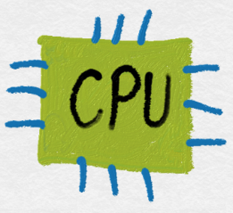



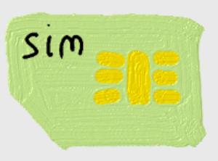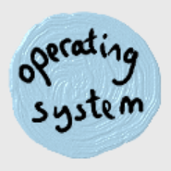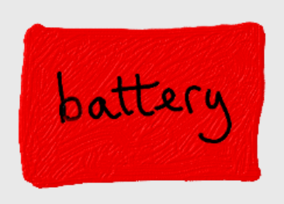

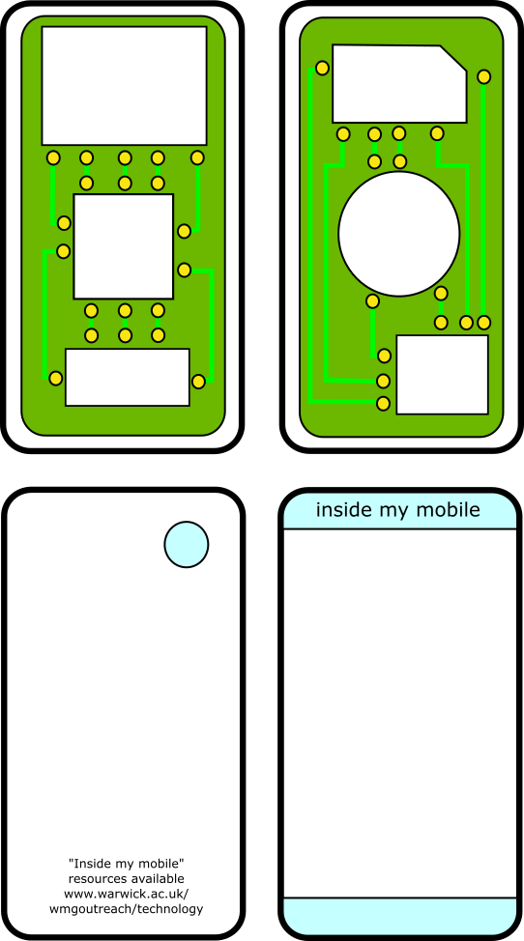

**Left or Right?**

Write two headers on a sheet of paper titled left and right.

**Activity 1** – write your name on a piece of paper. What hand did you use? Write hand under either left or right header.

**Activity 2** – place a coin on the floor directly in front of you. Step on the coin. Which foot did you use? Write foot under either the left or right header.

**Activity 3** – Use a paper or toilet cardboard tube and look at an object through it. Which eye did you use? Write eye under either the left or right header.

**Activity 4** – Make an imaginary phone call with a mobile phone. Which ear did you use? Write ear under either the left or right header.

Tally up the total for the left and right headers. Which total is the biggest? If it is left, then you mainly use the **left-side** of your brain. If it is right, then you mainly use the **right-side** of your brain. If it is equal, then you use **both sides** of your brain when doing activities that rely on your senses.

Why not repeat this experiment with other members of your family? What did you notice about their results? Were they the same or different? Were your family’s results what you expected?