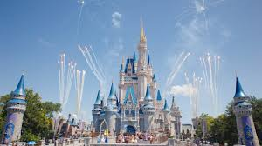
P1, P2/1 and P2 Virtual Disneyland Trip
We are going to DISNEYLAND, FLORIDA!! Let’s get started on our virtual adventure!
Monday
- Create a passport with a front cover, your name, a picture of yourself and space to include characters you see during the week!
- Take a tour of Donald Duck’s house boat. What can you see? Draw and label 5 things that you can see inside his house. Can you think of a story with Donald Duck’s house as the setting?
https://www.youtube.com/watch?v=XERRGapwSVQ
Tuesday
- Watch the video of Disneyland. Can you think of any rules or things you could do to keep safe at the park? Think about what you should do on rides, who you would speak to and any extra rules you can think of.
https://www.youtube.com/watch?v=mEyUzQUH-IY
- Look at the map of Disneyland. Can you find your way through the map?
- Start at the entrance and go to Donald Duck’s Boat
- Start and the log flume and go to the rollercoaster
- Start at the pond and go to the Frozen ride
CHALLENGE: Can you give detailed directions on how to get to each place?

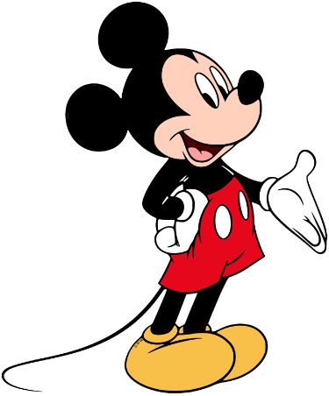

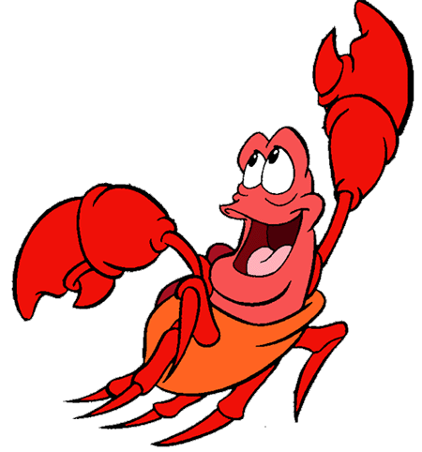
Wednesday
- Disneyland is in Orlando in America. Find out what the weather is like in Orlando today? Is it similar to our weather here? Are we hotter or colder? You could make a poster to show this.
- Listen to the song ‘Under the Sea’ from The Little Mermaid. Why does Sebastian (the crab) think it is better to live under the sea. Discuss with an adult at home.
https://www.youtube.com/watch?v=Fkusy4ylhiY&t=24s
Thursday
- Make a postcard to tell somebody all about your trip to Disneyland. You could send it to them or take photos to show them. You will need a picture on one side and write your message on the other side. CHALLENGE – can you write the person’s address?
- Here is a snack menu from Disneyland. Choose the snack you would like and the correct coins to pay for it. CHALLENGE – how much change would you get if you only had a 10p to pay with?

Friday – It’s your last day at Disneyland!!
- Watch the parade. Join in with the dancing or even make a mask to wear!
https://www.youtube.com/watch?v=rR-KP8KH1Ng
- Draw a picture of yourself at Disneyland and write a few sentences about yourself – post this to your Google Classroom for your new teacher to have a look and get to know you.

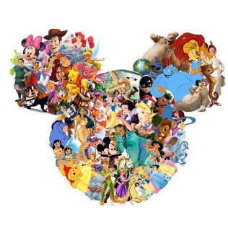
There are additional activities and links on the powerpoint that will be on Google Classroom. Enjoy

