Primary 6 Core Learning Tasks Week Beginning 15th June
Reading
LI: To skim and scan a text for key information.

Success Criteria:
-I can skim read a text briefly so help me understand what it is about.
-I understand how scanning the text helps me find relevant information.
-I have read the text carefully to help me fully understand it.
-I can create a fact file using the information collected and have included titles where necessary.

The text below is a non-fiction text. In class, we have done a lot of work on scanning and skimming first to help our understanding. Whilst you scan and skim, take notes.
After, read the text carefully and add to the notes you have if needed.
Create a short fact-file about what you have read. I would like you to use the headings:
- The Pyramids
- How long it took to build a pyramid?
- What do they look like?
- The Tomb
- The Sphinx
- The Afterlife
Include pictures if you would like, to make it more interesting.

The pyramids were the tombs that were built for the Pharaohs – the kings. The size f the pyramid was built to show the importance of the person who was buried in it. The ancient Egyptians believed that if a person was mummified that they would live forever, so they built these tombs to keep their bodies.
The most famous pyramid is the Great Pyramid, built for Pharaoh Khufu. When it was built it was over 140 metres height and took 20 years to build. It stands alongside many other smaller ones. The Great Pyramid has a rocky surface because the outer layer of rock has worn down. When the pyramid was originally built, it would have had an outer later or stone with a smooth appearance.
Inside the pyramid there are lots of hieroglyphics which tell the story of the pharaoh that was buried there. These would be used to tell the achievements and adventures of the Pharaoh. These hieroglyphics are why we know so much about the ancient Egyptian civilisation and people who ruled it.
There are over 130 pyramids that have been found in Egypt. The earliest pyramid is the Pyramid of Djoser which was built 2650 BC (roughly 4670 years ago)! The last pyramids were finished around 1800 BC.
The Egyptians believed that after you died, you would go into a new life. They also believed that when you did this, you would take all your belongings with you. Egyptian families would put things into the grave that they thought their dead loved ones would need.
The inside of an Egyptian tomb was quite complex. The body of the pharaoh was placed into a sarcophagus (a large stone coffin) which was then surrounded by other chambers, filled with items that they thought they would need in the afterlife. The tomb was decorated with gold items.
The sphinx had a body of a lion and the head of a Pharaoh. Sometimes, it would also have wings of a large bird. It was a mythical creature which was created to guard the pyramid and the tombs. The ancient Egyptians believed that the sphinx would ask those who wanted to enter riddles. Only if they got the riddles correct were, they allowed to answer!

Writing
LI: To write an imaginative story.
Success Criteria
-I have read and understood a story starter.
-I have used creative vocabulary.
-I can use a short text to create my own story.
-I remember to use everyday expectations when writing.

Task A
Read the passage below.

“Is that a cave?” asked Jimmy pointing to a dark spot on the cliff face. It was strange that he hadn’t spotted the cave before, as they had been to this same beach for the past three days. It was as though it had suddenly appeared from nowhere.
Beck, who had been busy building a sandcastle, looked towards the cliff. There, she spotted the cave he was pointing to. It was hard to see at first, due to the dark rocks surrounding the entrance but by looking carefully, he could just make it out.
“I wonder what’s inside?” he said aloud.
The two children walked along the beach towards the cliff face. The closer they got, the clearer the cave became. It was dark and foggy near the entrance. They felt a cold, deadly and eerie wind blow towards them. A shiver ran down their spine.

Task B
15-Minute write: How much can you write to complete the story, making it as interesting as possible.
Use the Chilli Challenge Writing Targets grid below to help improve your writing.

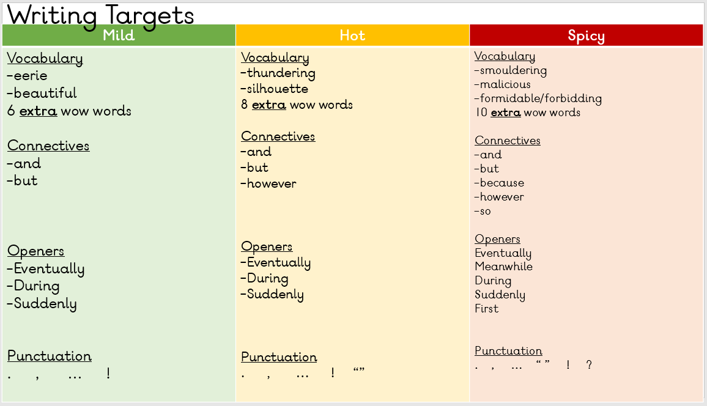

Numeracy
LI: To solve multiplication calculations using a range of strategies.
Success Criteria
- I understand that a number can be partitioned in different ways to help me multiply.
-I use my knowledge of place value to help me partition.
-I can use my knowledge of multiplication facts to help me solve calculations.
-I can multiply 3-digit by 2-digit numbers using the formal method.

Mild
a) 30 x 2= b) 10 x 3= c) 9 x 7 = d) 14 x 2=
e) 50 x 4= f) 6 x 5= g) 2 x 15 = h) 4 x 20 =

Hot
a) 13 x 3 = b) 15 x 2 = c) 9 x 11 = d) 24 x 2 =
e) 33 x 5 = f) 7 x 12 = g) 15 x 9 = h) 73 x 5 =

Spicy
a) 73 x 5 = b) 64 x 8 = c) 9 x 230 = d) 67 x 22 =
e) 900 x 5 = f) 313 x 54 = g) 250 x 4 = h) 73 x 725 =

