Primary 6 Core Learning Tasks Week Beginning 1st June
Reading
LI: To find information from a text.
The chapter, Expelled, is from a book called Groosham Grange by Anthony Horowitz. Read it carefully and answer the questions below. Remember to write in full sentences, use correct punctuation and include relevant detail.
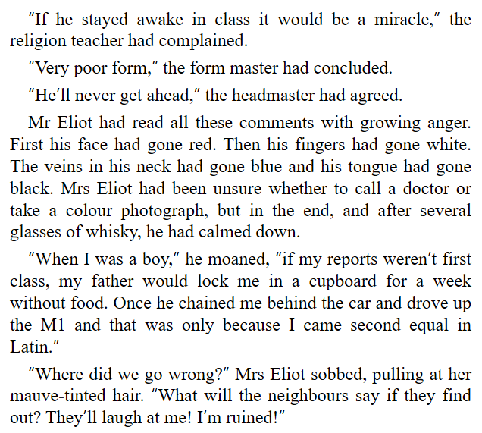
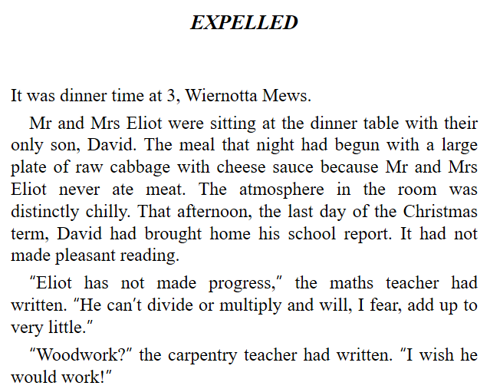

1. Look at the title of the chapter. What do you think the chapter will be about?
2. What did the family eat for dinner and why?
3. “It had not made pleasant reading.” What does this phrase suggest about his report?
4. A homophone is a set of words that sound the same but mean different things. What homophone pair can you see?
5. Why was Mrs Eliot thinking about taking a colour photograph?
6. What kind of childhood do you think Mr Eliot had? Explain your answer.
7. Imagine if you were writing a report for yourself. Write down 3 sentences you think would be on it.
8. Do you think the author likes to write in a humorous style? What clues/phrases from the extract help you decide? Explain your answer.
Writing
LI: To write an imaginative newspaper article.
Look at the titles below:
- Robots deliver furry babies
- Scorching sun leads to ice cream shortage
- Spider scares sturgeon
Choose one of the titles and write an article for it.
Success Criteria
-I have given detail about when, where, why, what and who in my article.
-I have written at least 3 paragraphs.
-I have included ambitious vocabulary.
-I have remembered my Everyday Expectations for writing.

Numeracy
LI: To solve calculations using a mix of the four operations.
Success Criteria
-I remember the order of BODMAS and understand its importance.
-I can apply the rules of BODMAS when solving calculations.
-I can use different strategies to solve a calculation.

