Primary 6 Core Learning Tasks Week Beginning 8th June
Listening and Talking
LI: To find key information through listening and watching.
Success Criteria
-I have listened and understood a current news article that I find interesting.
-I can write down key facts that I learned from this news clip.
-I can use Google and other sources to gather research this news story.
-I have created a detailed poster about my findings.

Task
Go onto the Newsround website (or another news website you enjoy) and listen to a news story that you find interesting. Watch and listen to it a few times.
Whilst watching the clip, write down at least 7 key facts that you have heard. Using the internet and other sources, what other key information can you find about this story?
Now create a detailed poster about this article to help others learn about it. Remember the Success Criteria needed to make a great poster: colourful, bold, catchy title and key information.

Numeracy
LI: To use a range of mental strategies for addition and subtraction.
Success Criteria
-I can use counting on to find the difference between two numbers.
-I can partition a number and count on or back using different parts to find the answer.
-I can use number facts to help me solve a variety of addition and subtraction calculations.

Task
Choose a suitable challenge for you. Try and solve the calculations mentally using a variety of strategies.
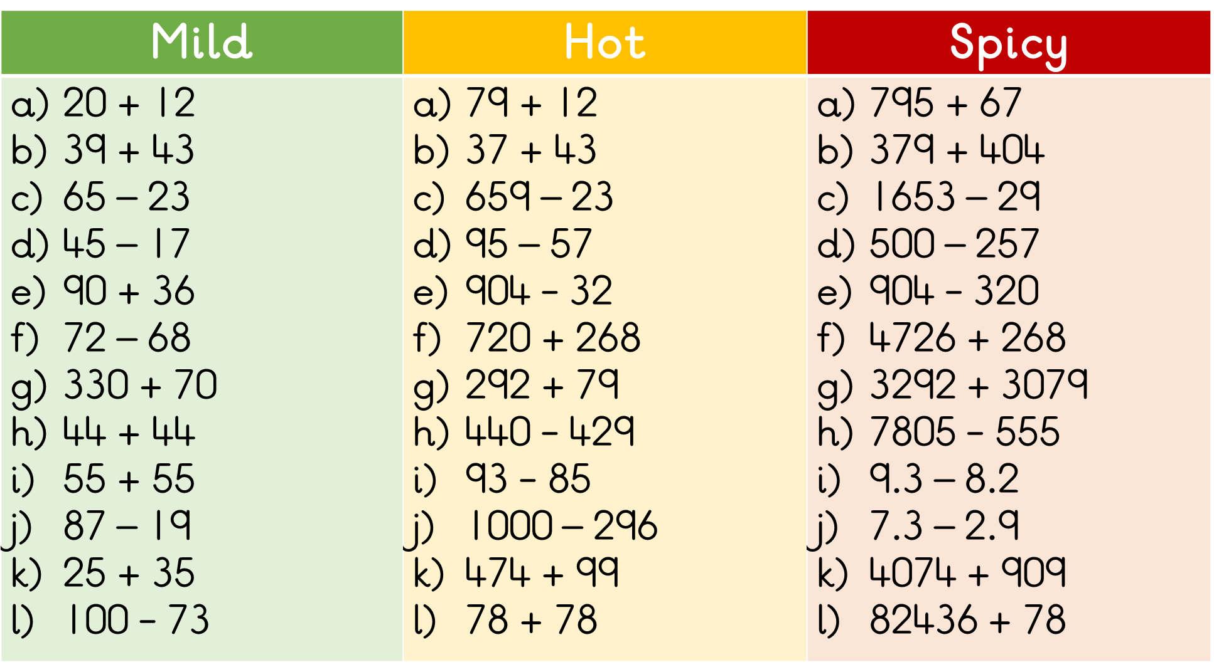

Maths
LI: To calculate the missing angle in a triangle.
Success Criteria
-I know that a right angle is always equal to 90°.
-I know that two angles which add up to 90° are known as complementary.
-I can find the value of a missing angle in a right angle.

Task
A right angle is always equal to 90°.
Look carefully at the right angles below. Each question has a set of complementary angles. Find the value of each missing angle so that is shows 90°. The first one has been done for you.
