Ancrum Road Primary School P5 Core Learning 
Listening & Talking Activity
Learning intention: To develop discussion and vocabulary.
Success Criteria:
- I can discuss earthquakes with another person
- I can learn some new words that I didn’t know some new vocabulary.
- I can select relevant information and display this in an organised and appropriate way for my purpose and my audience.

For a chilli challenge – Draw speech bubbles and try to include some of the descriptive words from the mat while people are communicating with each other during the earthquake.
Task
Draw a picture of a scene in an earthquake. Use 10 words from the Descriptive mat to label your drawing.
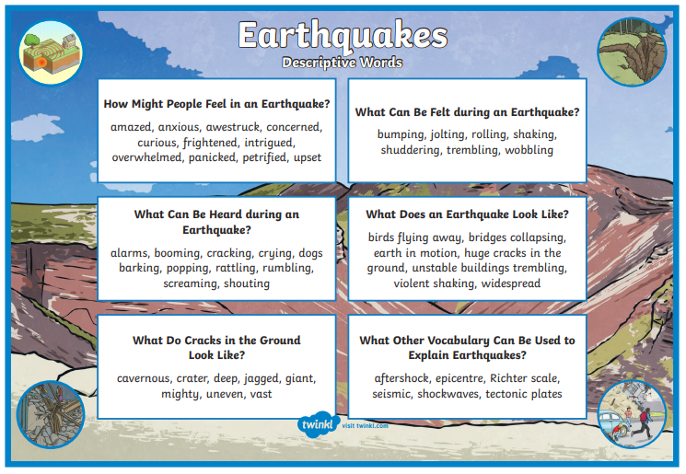
Numeracy Activity
Learning intention: To be able to recall the times tables to help develop mathematical skills
Success Criteria:
- I can recall mentally a range of times tables
- I can pick the appropriate level of maths for myself to complete (mild, hot etc)
- I understand that times tables help me with division, fractions, percentages and decimals. Times tables are one of the building blocks in mathematics.
Task

Maths Activity

Mild Task

Learning intention: - To add and subtract using number facts.
Success Criteria:
- I can subtract 1-digit numbers from 3-digit numbers mentally.

Subtract 5 from these numbers:
- 118
- 307
- 485
- 624
- 182
- 741

Subtract 7 from each of these numbers.
- 589
- 467
- 250
- 862
- 311
- 253

Subtract 9 from each of these numbers. (Think when subtracting 9, you can round it to 10 and then adjust.
- 589
- 367
- 724
- 211
- 785
- 324
- 308
- 702
- 401
Hot Task

Learning intention: - To round numbers to the nearest 10, 100 and 100. To add 2-digit numbers together.
Success Criteria:
- I can add two 2-digit numbers together

Round these numbers to the nearest 10, 100, 1000
- 73
- 165
- 723
- 9
- 380
- 566
- 421
- 248

Addition
- 42 + 23
- 26 + 41
- 55 + 24
- 33 + 46
- 36 + 45
- 28 + 33
- 38 + 44
- 63 + 29
- 45 + 38
- 63 + 72
- 44 + 74
- 83 + 54

Word Questions
- There are thirty-six cars parked on level 1 and 47 cars parked on level 2. How many cars are there altogether?

- Jane is 78cm tall. Chloe is 28cm taller than Jane. How tall is Chloe?
Spicy Task

Learning intention: - To add and subtract multiples of 10 and 100
Success Criteria:
- I can add the 10s and then the 100s
- I can add multiples of 1o and 100 to 4-digit numbers

Complete these additions
- 5673 + 20
- 9663 + 300
- 3456 + 40
- 5138 + 600
- 6835 + 50
- 8392 + 500
- 5251 + 50
- 3562 + 600
- 7894 + 30
- 1353 + 800
- 6875 + 50
- 8254 + 900
- 2442 + 80
- 2847 + 800
- 4860 + 120
- 7574 + 320
- 2385 + 510
- 5273 + 710
- 2578 + 420
- 7858 + 140
- 6684 + 130
- 2329 + 560

