Ancrum Road Primary School **P5 Core Learning** 

**Listening & Talking Activity**

Learning intention: To develop discussion and vocabulary.

Success Criteria:

* I can discuss earthquakes with another person
* I can learn some new words that I didn’t know some new vocabulary.
* I can select relevant information and display this in an organised and appropriate way for my purpose and my audience.

For a chilli challenge – Draw speech bubbles and try to include some of the descriptive words from the mat while people are communicating with each other during the earthquake.

**Task**

Draw a picture of a scene in an earthquake. Use 10 words from the Descriptive mat to label your drawing.

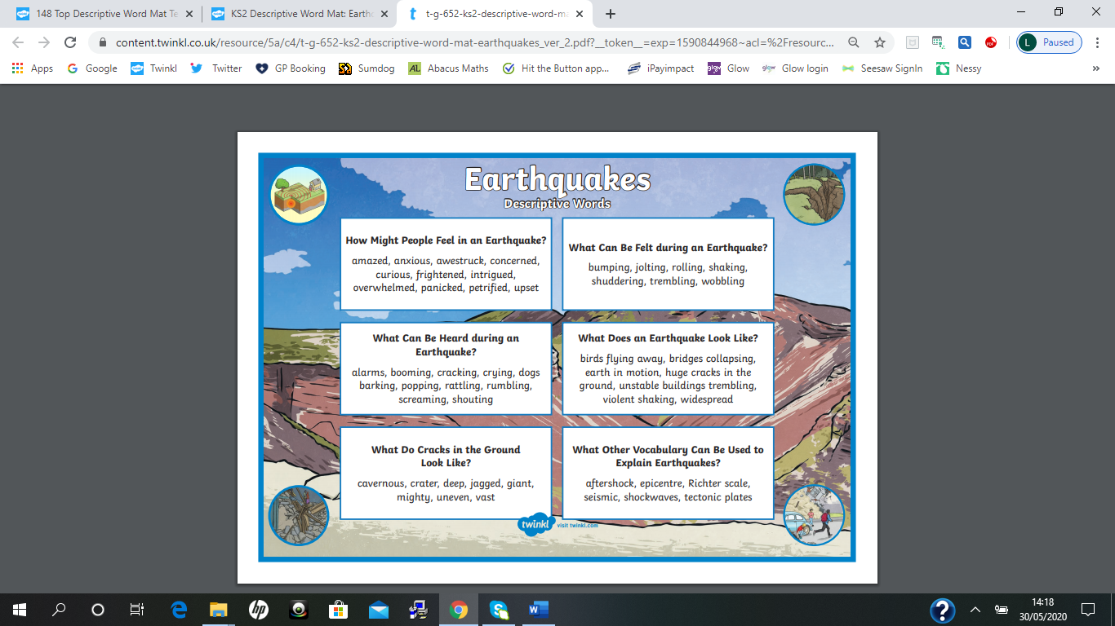

**Numeracy Activity**

Learning intention: To be able to recall the times tables to help develop mathematical skills

Success Criteria:

* I can recall mentally a range of times tables
* I can pick the appropriate level of maths for myself to complete (mild, hot etc)
* I understand that times tables help me with division, fractions, percentages and decimals. Times tables are one of the building blocks in mathematics.

**Task**



**Maths Activity**

**Mild Task**

Learning intention: - To add and subtract using number facts.

Success Criteria:

* I can subtract 1-digit numbers from 3-digit numbers mentally.

**Subtract 5 from these numbers:**

1. 118
2. 307
3. 485
4. 624
5. 182
6. 741

**Subtract 7 from each of these numbers.**

1. 589
2. 467
3. 250
4. 862
5. 311
6. 253

**Subtract 9 from each of these numbers. (Think when subtracting 9, you can round it to 10 and then adjust.**

1. 589
2. 367
3. 724
4. 211
5. 785
6. 324
7. 308
8. 702
9. 401

**Hot Task**

Learning intention: - To round numbers to the nearest 10, 100 and 100. To add 2-digit numbers together.

Success Criteria:

* I can add two 2-digit numbers together

**Round these numbers to the nearest 10, 100, 1000**

1. 73
2. 165
3. 723
4. 9
5. 380
6. 566
7. 421
8. 248

**Addition**

1. **42 + 23**
2. **26 + 41**
3. **55 + 24**
4. **33 + 46**
5. **36 + 45**
6. **28 + 33**
7. **38 + 44**
8. **63 + 29**
9. **45 + 38**
10. **63 + 72**
11. **44 + 74**
12. **83 + 54**

**Word Questions**

1. There are thirty-six cars parked on level 1 and 47 cars parked on level 2. How many cars are there altogether?
2. Jane is 78cm tall. Chloe is 28cm taller than Jane. How tall is Chloe?

**Spicy Task**

Learning intention: - To add and subtract multiples of 10 and 100

Success Criteria:

* I can add the 10s and then the 100s
* I can add multiples of 1o and 100 to 4-digit numbers

**Complete these additions**

1. **5673 + 20**
2. **9663 + 300**
3. **3456 + 40**
4. **5138 + 600**
5. **6835 + 50**
6. **8392 + 500**
7. **5251 + 50**
8. **3562 + 600**
9. **7894 + 30**
10. **1353 + 800**
11. **6875 + 50**
12. **8254 + 900**
13. **2442 + 80**
14. **2847 + 800**
15. **4860 + 120**
16. **7574 + 320**
17. **2385 + 510**
18. **5273 + 710**
19. **2578 + 420**
20. **7858 + 140**
21. **6684 + 130**
22. **2329 + 560**