Listening & Talking Activity
Learning Intention: I am learning how to engage with others. LIT 1-02a
Success Criteria:
- I can communicate clearly.
- I can ask different types of questions.
- I can listen carefully.
- I can respond with respect.
Task
Interview someone that you live with (or someone you know by video call/phone call) about their job or favourite hobbies. Brainstorm questions prior to the interview thinking about exactly what you want to find out. Use a variety of different question starters – what/who/why/when/where/how etc.

Numeracy Activity
Learning Intention: I am learning to use a range of subtracting strategies to find an answer. MNU 1-03a
Success Criteria:
- I can pick a strategy – partitioning/empty number line/counting on/concrete materials.
- I can accurately answer a sum.
- I can read an answer to see if it makes sense.
Task
This year in numeracy we have practised lots of ways to subtract. We might split the numbers into their hundreds, tens and ones and subtract these separately (partitioning). We might write down some working or draw hops on an empty number line. We might count back to help find the answer. We may wish to use concrete materials and always remember you will be taking away from the biggest number.
Remember
- Pick a chilli challenge that you think suits you
- Read each sum carefully and decide how you could figure it out.
- Find the answer then look back to see if it makes sense.

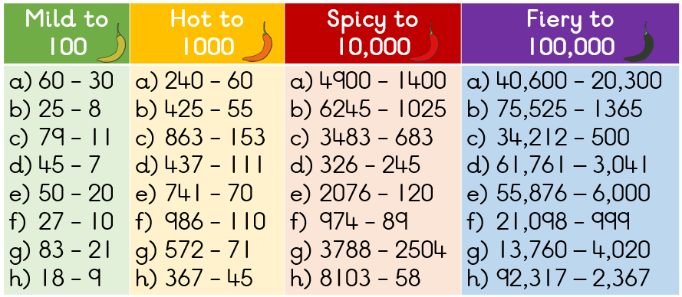

Maths Activity
Learning Intention: I am learning ways to collect information and sort it in a logical and organised way. MNU 1-20b
Success Criteria:
- I can find out information.
- I can display the data.
- I can label the axis.
- I can ask questions about my graph.
Task
Before we left school, we learnt that graphs are used to answer questions about real-life situations and how they help us to understand data. We learnt how to compare data and draw conclusions about it. We practised displaying information in pictograms, block graphs and bar graphs.
Can you now use these skills to organise information at home? Ask 10 people by phone/video call, or ask your teachers and classmates on our TEAMS page. Remember you will need to think carefully about what you are wanting to find out – favourite hobby, food, eye colour, sporting activity, etc.
(If you are struggling to find people to ask, why not watch a favourite TV show and record the hair colour of 10 characters?)
MILD: Decide what you are wanting to ask, and create a table to record the answers you find out.
HOT: Create a graph (pictogram or block graph) to show the results. Make sure your graph has a title and that you have labelled the axis.
SPICY: What questions can you ask about your findings? (e.g. what was most popular?) What conclusions can you make?

