P3 Core Learning Tasks
Writing
Learning Intention – To use descriptive language (adjectives) in writing
Success Criteria –
- Look at the image below and think of the words that come to mind (you could begin by creating a list of adjectives to include in your writing)
- Write a paragraph (roughly 10 sentences) about approaching the door
- Include capital letters, full stops and finger spaces
- Highlight the adjective you manage to include
Let’s imagine you have just been hired as a creative writer and your boss calls you with an assignment. Use as many of the prompts as you can to help you make your writing descriptive. Post your descriptions to our Teams for feedback on your WOW words.
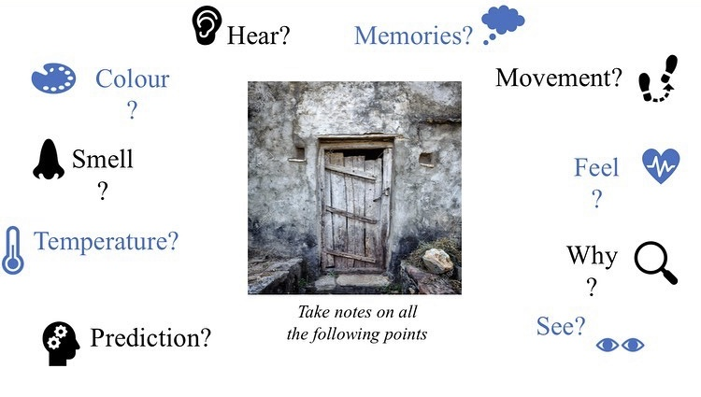
“We need you to write about a door. The character is walking towards the door and we need it to be MEGA descriptive. Use the photo for inspiration”.

Reading
Learning Intention – To investigate different ways authors use language creatively
Success Criteria –
- Read a story at home, carefully
- Think about the words and phrases the author has chosen to use
- Consider different words or phrases the author could have used, discuss with an adult

Numeracy
Learning Intention – To know division facts for 2, 5, and 10 times tables.
Success Criteria –
- I can write down the division facts for these tables.
- I can remember that multiplication and division are related.
Practise writing down the division number sentences for times tables we have learned. You can practise this further by assessing the website below and selecting the division facts you want to get better/faster at. https://www.topmarks.co.uk/maths-games/hit-the-button

