P2 Core Work
Literacy – Listening & Talking
Learning Intention:
- To listen and talk in different situations. LIT 0-02a.
Success Criteria:
- I can share an item that is special to me with someone
- I can talk in detail about my special item
- I can respond appropriately to questions about my special item
Choose an object you have at home that is special to you. Tell your adult
- What your object is
- When you got it
- Where you got it from
- Who it was from
- Why it means a lot to you
Your adult may want to ask you some extra questions about your object, so listen carefully and answer them as best you can. You can ask you adult to write down what you say and send your answers in with a photo of your object. Or, if you like, you could ask your adult to video you speaking about your object and send that in.

Numeracy
Learning Intention
- To recognise and use coins to give change. MNU 1-09a.
Success Criteria
- I know how much money I can spend.
- I can use subtraction to work out my change.
- I can say how much money I have left.
Choose a challenge and work out how much change you would get at the shop. Use materials to help you count and subtract if needed.

Mild | Hot | Spicy | Fiery
You go to the shop with 20p and buy the apple. How much change will you get?  11p | You go to the shop with 50p and buy the cupcake. How much change will you get?  37p | You go to the shop with £1 and buy the tennis ball. How much change will you get?  82p | You go to the shop with £10 and buy this book. How much change will you get?  £6.10

Maths
Learning Intention:
- To read analogue and digital clocks. MNU 1-10a
Success Criteria:
- I can read o’clock, half past or quarter to/past on an analogue clock
- I can read o’clock, half past or quarter to/past on a digital clock

Choose a challenge below to complete.

Mild | Hot | Spicy
____ o’clock  ____ o’clock  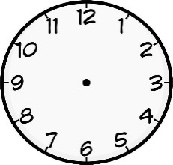  10 o’clock  ____ o’clock  ____ o’clock  12 o’clock | 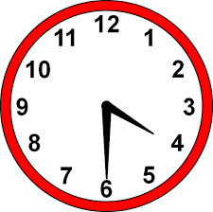  Half past ____  Half past ____  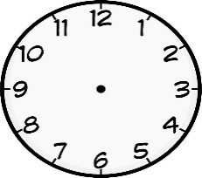  Half past 7  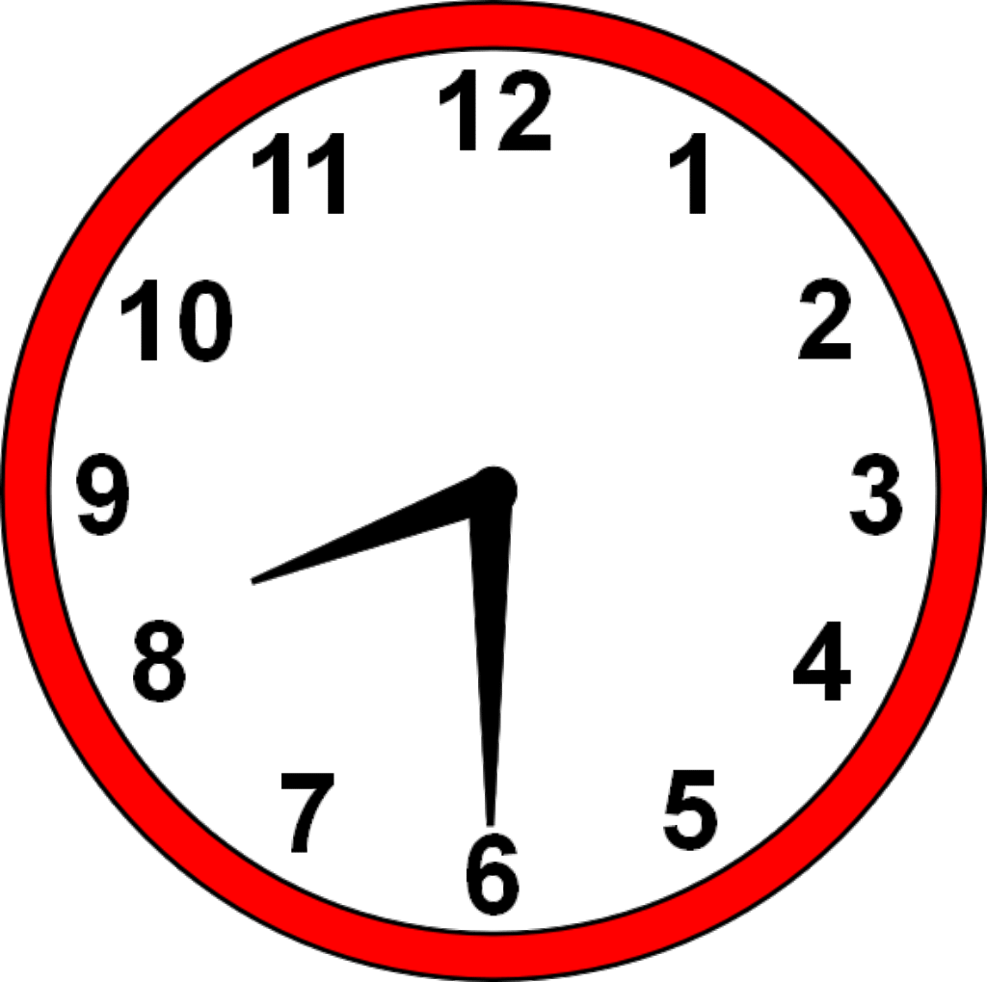  Half past ____  Half past ____  Half past 2 | Quarter past 10  Quarter past 4  Quarter past 6  Quarter to ____  Quarter to ____  Quarter to 8

