P1 Core Work

Literacy - Reading
Choose a story to read with an adult. Look out for red words and tell them to your adult? Write them down and share with us on google classroom.
Learning Intention:
- To use what I have learnt to read and write.
Success Criteria:
- I can identify red words in a story.
- I can write red words and try to remember how to spell them.
Examples of red words to look out for – the, my, of, he, she, said, put, by.

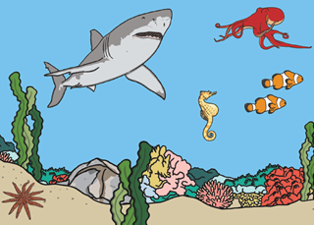
Literacy – Writing
Write words and/or sentences to describe the picture.
Learning Intention:
- To write about and describe a picture. ENG 0-12a
Success Criteria:
- I can write words and/or sentences to describe a picture.
- I can sound words out.
- I can include capital letters, full stops and finger spaces in my sentences.

Numeracy
Learning Intention:
- To explore numbers and what they represent. MNU 0-02a
Success Criteria:
- I know that even numbers end in 0, 2, 4, 6, 8.
- I know that odd numbers end in 1, 3, 5, 7, 9.
Create a table like below and put the following numbers into the correct column in the table.
Odd | Even
*insert numbers here* | *insert numbers here*

Mild – 15, 8, 19, 1, 5, 12, 20

Hot – 30, 25, 42, 40, 49, 33, 50

Spicy - 88, 75, 62, 100, 90, 53, 61

Fiery – 150, 222, 531, 999, 437, 638, 1001

Extension task: play this game to practise more odd and even numbers. https://www.topmarks.co.uk/learning-to-count/coconut-odd-or-even

