P1 Core Work

Literacy – Listening & Talking
Learning Intention:
- To listen and talk in different situations. LIT 0-02a
Success Criteria:
- I can ask questions that are relevant.
- I can listen carefully to what my adult says.

Ask your adult to think of an object in your house.
Try to guess the object by only asking ‘where’ questions: e.g Would I find this object in my room? Would I find this object in the kitchen? Etc.
How many questions did it take before you got the correct answer?
Now swap roles and your adult can ask you the questions!

Numeracy
Learning Intention
- To recognise and use a range of coins. MNU 0-09a
Success Criteria
- I know how much money I can spend.
- I can use subtraction to work out my change.
- I can say how much money I have left.
Choose a challenge and work out how much change you would get at the shop. Use materials to help you count and subtract if needed.
Mild | Hot | Spicy
You go to the shop with 10p and buy the apple. How much change will you get?  5p | You go to the shop with 20p and buy the cupcake. How much change will you get?  8p | You go to the shop with 50p and buy the tennis ball. How much change will you get?  27p

Maths
Learning Intention:
- To explore digital and analogue clocks. MNU 0-10a
Success Criteria:
- I can identify o’clock on an analogue clock
- I can identify o’clock on a digital clock
Choose a challenge below to complete.
Mild – what time is it? | Hot – what time is it? | Spicy – draw the time.
____ o’clock  ____ o’clock  ____ o’clock | ____ o’clock  ____ o’clock  ____ o’clock | 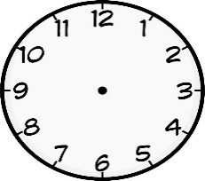  8 o’clock  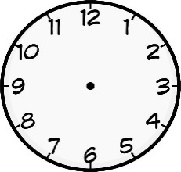  1 o’clock  12 o’clock

Go to https:// www.doorwayonline.org.uk/timeandmoney/abouttime/ Choose ‘What time is it?’ activity and set to 1 hour intervals for further practise.

